**Job Location Suggestions Using Machine Learning**

Aswini Pusuluri

Gianni Deguzman

Sowmya Ravichandran

Vishalakshi Ramanathan

Department of Data Analytics, San Jose State University

Data 245: Machine Learning Technologies

Dr. Shih Yu Chang

December 4, 2021

Table of Contents

Job Location Suggestions Using Machine Learning 3

Problem Definition 3

Project Background 3

Literature Survey 4

Project Objectives 6

Project Management Plan 7

Multidisciplinary Analysis 10

Data Preparation 10

Models 15

Decision Tree: 15

K-Nearest Neighbors 19

AdaBoost: 22

XGBoost 26

Results 29

Decision tree 30

K- Nearest Neighbor 32

AdaBoost 34

XGBoost 36

Discussion 39

Evaluation and Reflection 40

Decision Tree 42

K-Nearest Neighbor 46

Adaboost 50

XGBoost 53

Model Deployment 55

Future work 58

References 60

# Job Location Suggestions Using Machine Learning

## Problem Definition

### Project Background

Educational and occupational choices are important since they influence a person's standard of living; however, the location of employment is equally important because everyone wants to live in a tranquil environment that suits their preferences. A study was conducted to learn more about why people frequently relocate in order to find work or accept a job, and it was discovered that a variety of factors, including cost of living and taxes, high paying state or city as well as a variety of other considerations known as amenities, all play a role in deciding where to go. Workers benefit from favorable weather, clean air, little crime, easy access to cultural activities, and more job opportunities. Geographical location plays an important role in deciding the wages. For instance, in the United States of America there are 50 states, and each state has a different PayScale for a particular job position. For instance, Florida, has the lowest median earnings at $26,000, while California, has the highest median earnings at $65,000.

Similarly, when it comes to living, some people prefer a hotter climate than a colder climate. Weather can have a big impact on how much a person enjoys living in a given place. When it comes to violent crime, towns with the lowest rates have a variety of other socioeconomic characteristics in common, the most prominent of which is economic wealth. Furthermore, work options are dependent on the location in which an individual might have a good job prospect. There is presently no mechanism for determining a person's ideal location, but we can use machine learning methods to accomplish it.

Currently there are many websites such as glass door, levels fyi where the salary is predicted based on location , job roles ,years of experience and so on. But there is no mechanism to predict the location based on the individual's preference. It requires extensive time to research on various factors to decide any job location. The location prediction model greatly cuts down the time spent and provides focal points of research.

### Literature Survey

Applying data mining techniques in job recommender system for considering candidate job preferences

In this study, the author proposed job suggestions based on applicant profile matching as well as maintaining candidate job behavior or preferences. The qualities that were discovered to be significant in an employment situation were divided into two key categories: Candidate and Job. Then rules are mined that anticipate the general preferences of various user groups. The target applicant's job suggestions are then created based on content-based matching as well as candidate preferences, which are saved either in the form of mined rules or retrieved from the candidate's own applied job history. Tracking the candidate's current job preferences allows you to prioritize just the relevant jobs above the irrelevant opportunities that are shortlisted once the candidate's content is matched. Decision tree was used for this project and this approach yields 92% accuracy.

Job Prediction from Deep Neural Network Models to Applications. The author focused on job prediction using several deep neural network models such as TextCNN, Bi-GRU-LSTM-CNN, and Bi-GRU-CNN with various pre-trained word embeddings. A simple and successful ensemble model incorporating several deep neural network models was also suggested by the author. Before feeding the data to the models, the data was preprocessed and segmented into a collection of words. The robustness of Bi-GRU-CNN with the word embedding Glove has been demonstrated, and it outperforms other models. With an F1-score of 72.71 percent, the suggested ensemble model produced the best outcomes in the experiments.

A smart Geo-Location Job Recommender System Based on Social Media Posts. Because of the vast number of services available, social media has become a day-to-day use for the majority of Internet users. Through virtual networks, social media allows people to exchange their opinions and facts. The proposed work focuses on building a smart job-search system based on the geo-location of the client. This paper suggests a clever system that scans social media networks like Twitter and Facebook to find the ideal employment for each individual job seeker. The matches were chosen based on the client's geo-locations, which were discovered through a search of their social media posts. Because it uses sophisticated recommender algorithms, this system outperforms recent similar systems. This paper used classifiers such as NB, SVM, and RF to classify the geo location of the client and achieved 77.04% accuracy.

Users click prediction for personalized job recommendation. The suggested method focuses on the component of recommendation and rating. The author generated a collection of attributes that reflect the click behavior of individual job seekers based on observations of a huge number of users' click patterns in a major job search engine. Furthermore, patterns of missing attributes may suggest the presence of diverse sorts of job searchers. Learn the associated prediction models for individual clusters using a probabilistic model that groups users based on missing attributes. The EM technique is used to estimate the parameters in this clustering-prediction process. The author used a real-world testbed to compare several models such as PCP and Logistic regression. PCP surpasses logistic regression with 75% accuracy.

A Job Recommendation Machine Learning Model Using Elderly Lifestyles. The aging society is one of the most fundamental societal developments of our time. The Baby Boomer generation is currently the largest demographic in our culture. This generation of older folks appears to have distinct lives and traits than previous generations. They are more likely to work into their later years. Assessing their demographics may not be enough when proposing a career for this group. Using a machine learning method, this research proposes career recommendations based on older lifestyles. The study's participants were senior people from Bangkok. A logistic regression algorithm was used to create the machine learning model in the R programming language. This paper used Logistic Regression and achieved 91.20 percent accuracy; the model can propose a job for seniors. The study introduces the notion of employment suggestions for the elderly based on their background, habits, and contemporary quality of life norms, as well as an empirical model for doing so.

# Project Objectives

We are at a point in our studies and careers where we are looking forward to our future job roles and need to consider where to settle. The location prediction model greatly cuts down the time spent and provides focal points of research. The main goal of this project is to create a machine learning model which predicts a location based on our needs such as salary, weather, prospects, crime rate, affordability, economy, and quality of life.

An analytical approach is proposed where the preferred location of an individual is predicted using a query which includes features such as the Job Title, Years of Experience, Salary, weather, prospects, crime rate, affordability, economy, and quality of life. To achieve the objective, the information of various job titles, salary for each job role based on location, years of experience, education is collected from the levels_fyi job search portal, the locations are ranked based on the climatic conditions taken from the National Centers for Environmental Information, the job opportunity rankings were obtained from the Economist Intelligence Unit consisting of different Federal Bureaus like Labor Statistics, U.S Census Bureau, National Science Foundation. The affordability, economy, education and health, quality of life and safety is taken from the Bureau of Labor Statistics. The above features are required to accurately predict the preferred location and hence all the above features were merged into a dataset. We performed various pre-processing and data cleaning techniques to get the data ready for modelling such as using ordinal encoder, one-hot encoding, binning and so on. The location prediction is a multiclass classification problem, hence the following machine learning models were utilised such as Decision Tree, K- nearest neighbour, AdaBoost and XGBoost. We built the Decision Tree model from scratch and K- nearest neighbour, AdaBoost and XGBoost using the Scikit-Learn library. The dataset was fit to models and the hyper parameters were tuned on the validation set and the performance was evaluated using the testing dataset. The best multi-class classification models are selected by performing various evaluation metrics for each model and the algorithm producing the higher accuracy rate is selected to solve the location prediction problem.

## Project Management Plan

This project is built on the CRISP-DM (Cross-Industry Standard Process for Data Mining) process model, which is based on the six phases of the data science life cycle, as stated below.

To ensure that the deliverables and scope are linked in a progressive way, this project follows a work breakdown structure. The CRISP-DM process model is used to create the work breakdown structure, which provides effective planning, execution, monitoring, and control. This will also function as a source of truth for the project's various phases of execution. The CRISP-DM process model serves as a roadmap for the various phases of this project's implementation. The road map for this project is divided into six phases according to the CRISP-DM methodology. Business Understanding, Data Understanding, Data Preparation, Modeling, Evaluation, and Deployment are the steps in the process.

**Figure 1**

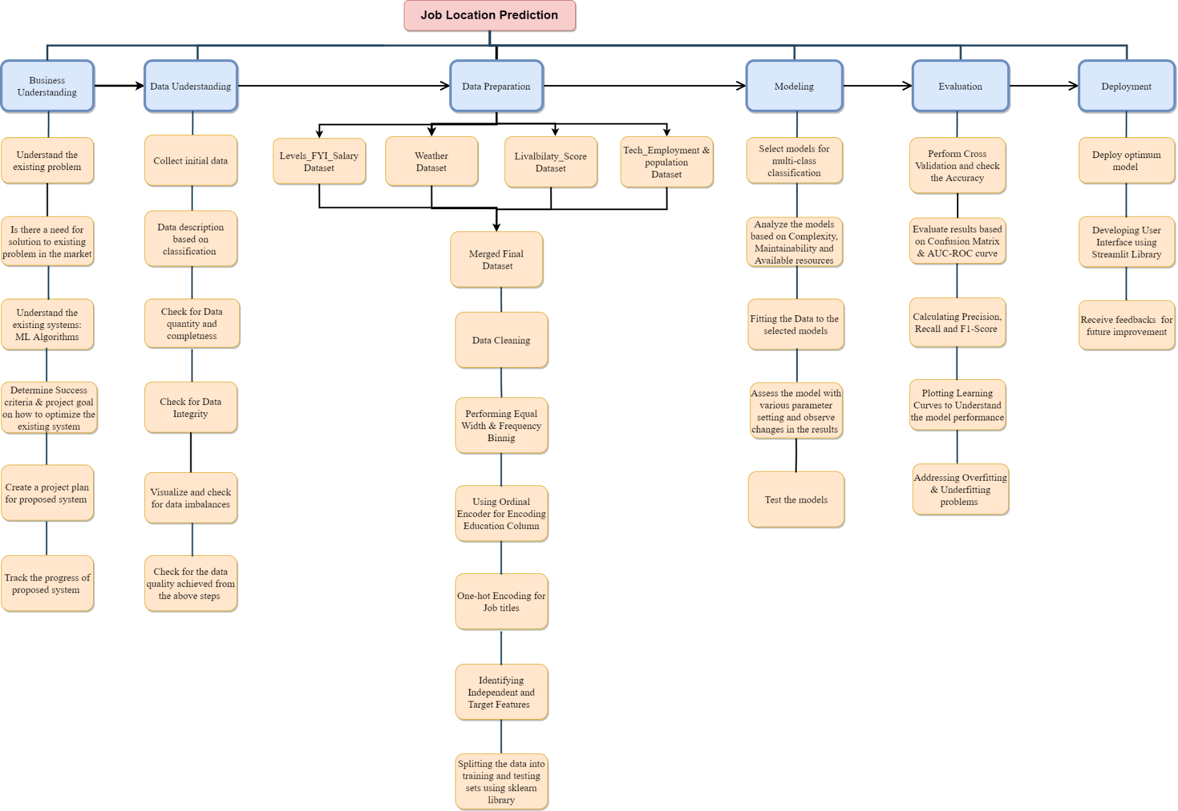

The first step of the project is the Business Understanding phase, which focuses on determining the current difficulties with the job placement prediction approaches in place and their accompanying algorithms. The Business Understanding phase will be completed by laying up a project plan with success criteria and information relevant to optimization of existing techniques, as well as mechanisms to track the development of the suggested methods. There are several processes in the Data Understanding phase. The data gathering stage includes a list of the data source, the technique utilized to obtain the data, and any obstacles encountered throughout the data collecting process. The data description and data exploration procedures entail a detailed explanation of the data source as well as an examination of the gathered test data. Data quality is the final stage in Data Understanding, and it maintains data integrity by ensuring that anomalies in the data are eliminated and qualified data with completeness is considered for the future phases of data processing.

Pre-processing procedures are used in the data preparation phase to produce data that will be supplied into the modeling phase. Modeling is the fourth step of the Work Breakdown Structure, and it specifies the data assumptions based on the various modeling types employed and the data to be trained. Model optimization methods and a testing strategy are also included in this step. The fifth phase is the evaluation phase, which is used to determine the accuracy and compare the performance of various models. If any mistakes or flaws are discovered, a remodeling step is necessary; otherwise, the best model is moved to the deployment phase.The last process is Deployment, which entails deploying the best model.

# Multidisciplinary Analysis

## Data Preparation

As illustrated in Figure 2, The collected data from level_fyi has 62642 records and 29 columns. The data consists of company name, job title, levels, tag, yearly compensation, base salary, bonus, education, years of experience, company location and so on. As shown in Figure 3 weather data contains weather rank for each state in the United States. As shown in Figure 4 livability score data consists of affordability score, economy score, education and health score, quality of life score and safety score for each state. As shown in Figure 5, job opportunity data contains the rank for each state that are related to the overall scope of the jobs.

**Figure 2**

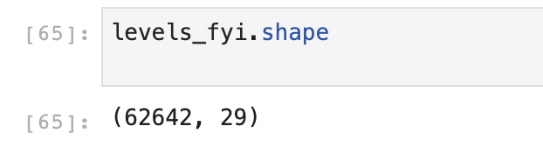

**Figure 3**

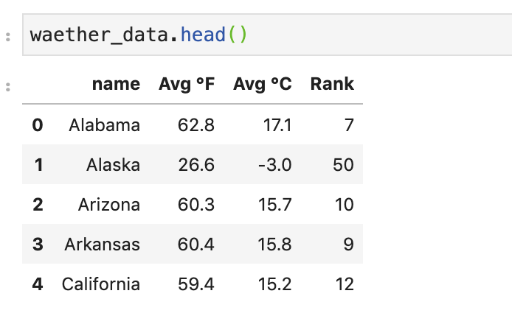

**Figure 4**

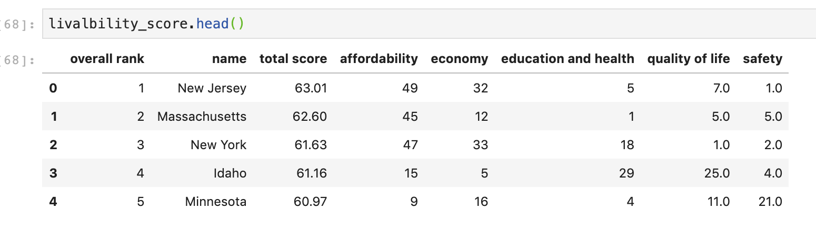

**Figure 5**

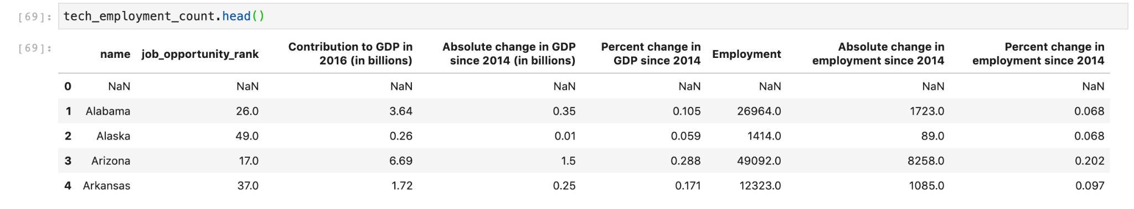

From the above dataset, as shown in Figure 6 we split location column values into city, state and country. As we are focusing on the United States, we dropped records which have other countries. And then we combined Weather data, job opportunity data and Livability data based on the states. After combining the data, we dropped the columns which don't have any relationship with the target value which is shown in Figure 7. Our dataset doesn’t contain missing values and also, we renamed the column names to their appropriate names. Job opportunity data, livability data and Weather data contains rank and scores for each state in the United States. So, in order to reduce the noise and non-linearity in the dataset, as illustrated in Figure 8 and Figure 9 we performed binning to transform the numerical values into five different categorical values. As shown in Figure 10 we used equal width binning for livability score and weather score in order to have a set of range values in each binning. As we are dealing with rank in job opportunity data, we used equal frequency binning to have the same length in each binning which is illustrated in Figure 11. Education column in the dataset has five categorical values such as PhD, Graduate, Undergraduate, High School and others. As shown in Figure 12 to transform the categorical values in the education column to numerical we used ordinal encoding. Ordinal encoding is nothing, but each unique label is mapped to an integer value in an ordinal encoding. Only if there is a known link between the categories is this form of encoding suitable. Therefore, by performing ordinal encoding we transformed PhD as 0, Graduate as 1, Undergraduate as 2, High School as 3 and others as 4. And the remaining values which don't fall into these five categories are converted to -1.

**Figure 6**

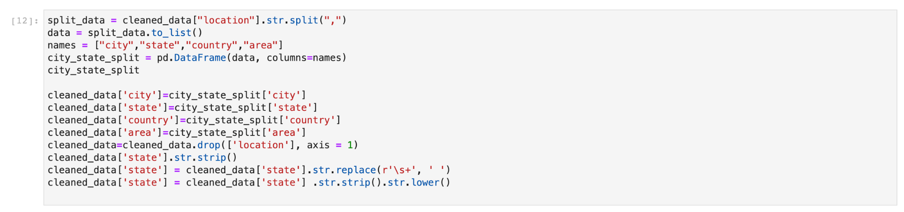

**Figure 7**

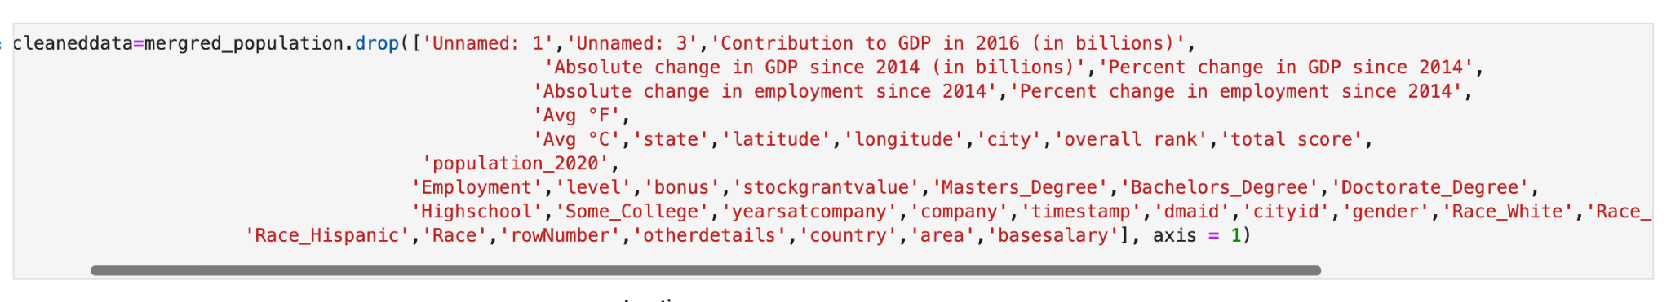

**Figure 8**

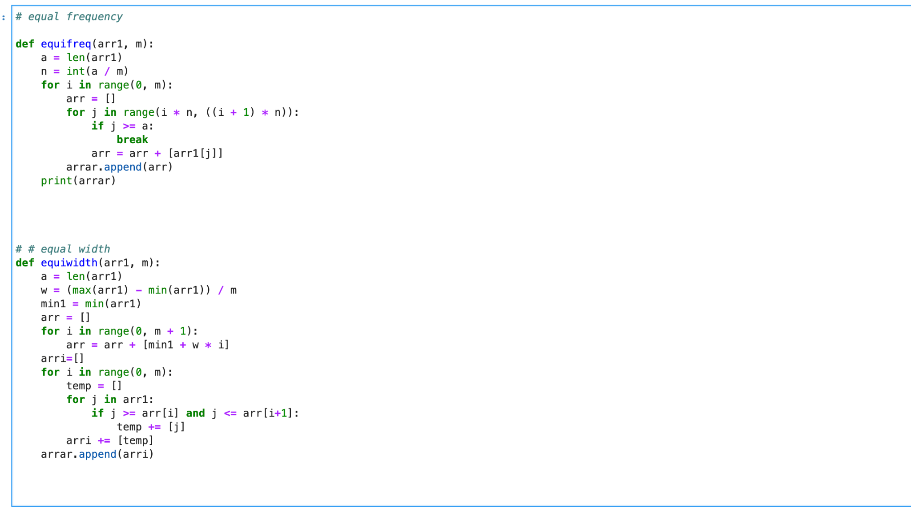

**Figure 9**

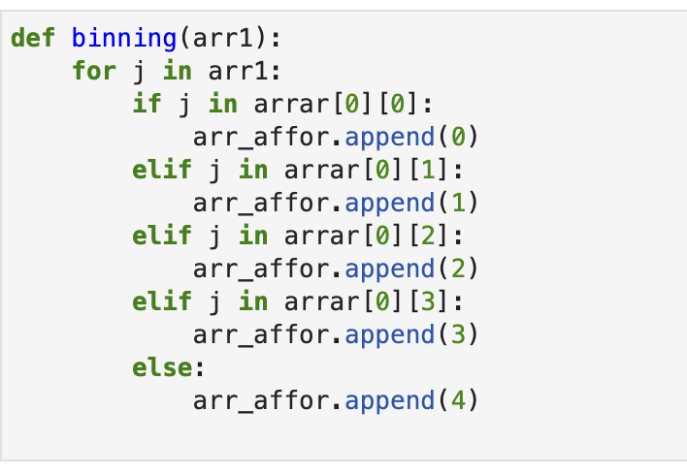

**Figure 10**

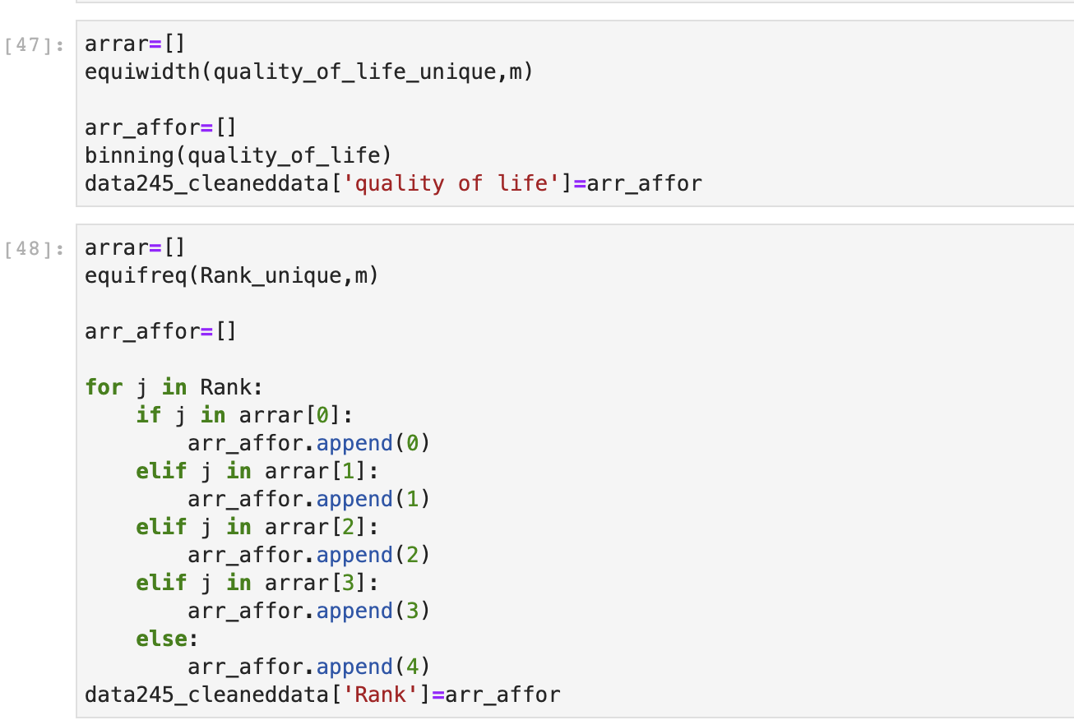

**Figure 11**

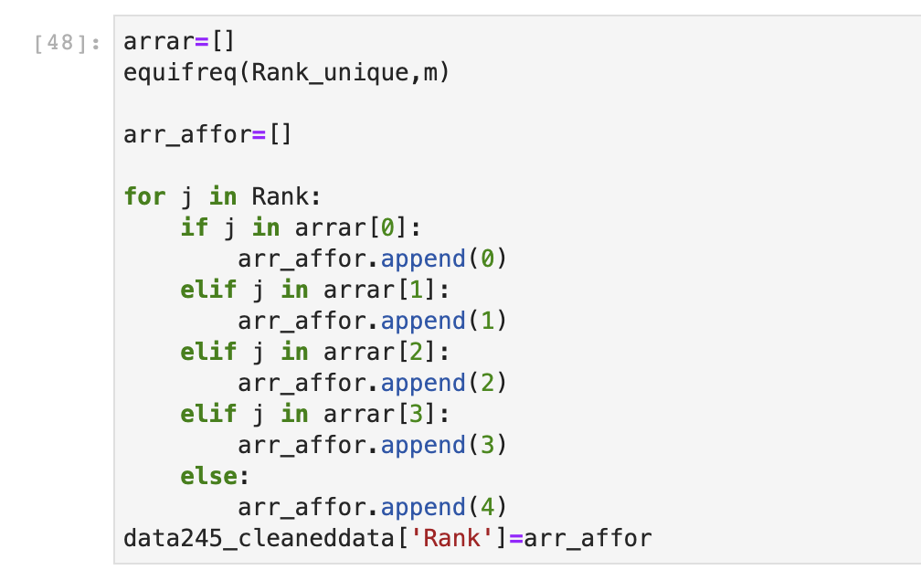

**Figure 12**

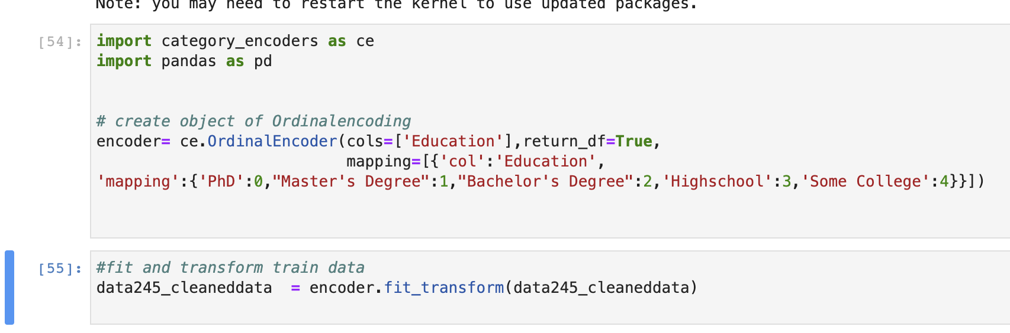

The dataset used for this machine learning model has 52245 records and 12 columns with the training dataset accounting for 70% of the total data points. The modified data must be separated into three sets during the data preparation phase: test, train, and validation. The train test split function from the scikit-learn library is often used to split the dataset into the train, test, and validation datasets. The training set trains the model, the validation dataset assesses the performance, and the testing dataset validates the model correctness before deployment. In our case we have unbalanced target values in our dataset. Therefore, it’s preferable to divide the dataset into train and test sets in such a way that the proportions of instances in each class remain the same as they were in the original dataset. In order to achieve that we used stratify the target variable when splitting the dataset into testing and training. The validation dataset verifies the model by rotating around the dataset and testing it with different sets of values. As we have a unbalanced target classes, Therefore we used the stratified K-Fold-Cross-Validation approach, the dataset is divided into many segments by the k parameter; all of the segments are used to train the model except one, which will be used to test the model; this is repeated until the model is tested by all of the segments. The model's minimum and maximum accuracy are determined by the average outcomes of all folds. To begin, a small sample of data is chosen, and the model is trained on it. The test results are utilized to forecast future points. These projected points will be included in the following iteration. This procedure is continued until all data points have been verified. Each iteration's accuracy score is recorded. The average accuracy value is obtained once all of the iterations have been completed. This figure indicates the model's maximum and lowest accuracy, as well as the fact that it has been trained and tested with all of the data from various angles. Hence, in order to build the machine learning model to predict the location based on the preferences we used 70% of the dataset is used for the training model, 15% for testing and 15% for validation.

## Models

### Decision Tree:

A Decision Tree is supervised machine learning in which data is constantly separated according to a parameter. Taking a collection of pre-classified examples as input, determining which characteristics to divide the dataset on, splitting the dataset, then recursing on the split datasets until all training instances are categorized. The purpose of splitting on the characteristics that generate the cleanest child nodes possible when creating our tree is to minimize the number of splits required to categorize all instances in our dataset to a minimum. One of a number of distinct attribute selection measures is used to determine purity.

Purity is quantified in decision tree by the idea of information gain, which is based on Claude Shannon's work and refers to how much information about a previously unknown instance would need to be learned in order for it to be properly categorized. In practice, entropy, or the amount of information required to classify a single instance of a current dataset partition, is compared to the amount of information required to classify a single instance if the current dataset partition were to be further partitioned on a particular attribute. The property that gives the greatest amount of information gain is used to separate this division. Pseudocode for decision tree algorithm, is shown in Figure below

**Figure 13**

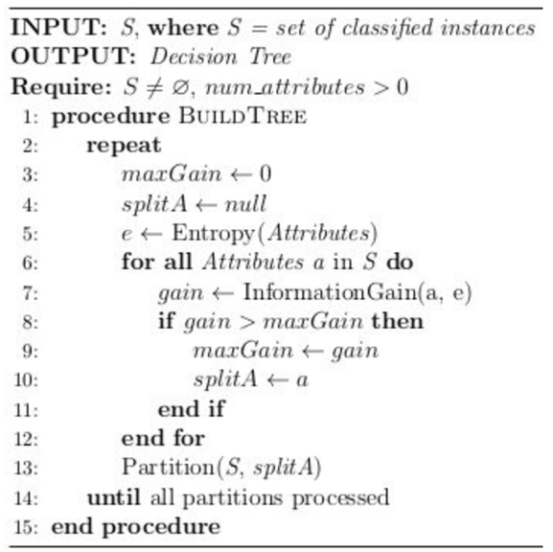

Entropy and Gini Index are used to determine impurity in the samples for this project. Entropy is the quantity of data required to correctly characterize a sample. So, if the sample is homogeneous, meaning that all of the elements are comparable, the entropy is zero; otherwise, if the sample is evenly split, the entropy is maximum 1. Entropy is expressed mathematically as below where pi is the probability of each class.

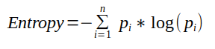

The Gini index is a measure of sample inequality. It has a value of 0 to 0.5. A Gini index of 0 indicates that the sample is totally homogenous and that all elements are comparable, whereas a Gini index of 0.5 indicates that there is the most inequality among the items. It's the sum of the squares of each class's probability. Gini index is expressed mathematically as below where pi is the probability of each class.

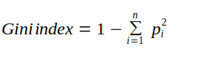

Among all the input features given to the decision tree, job_opportunity rank has the maximum information gain and entropy with 2.785 hence job_opportunity_rank is used as root node and other attributes are further partitioned by computing information gain at each child node. We can observe from the tree diagram below that job opportunity rank has two child nodes, which are economy and climate. Both the economy and the climate have child nodes, which are quality of life, education, health, and affordability, that are further partitioned using information gain calculations. This procedure continues untill leaf node tree with the majority class of the dataset as its classification if the list of characteristics remaining to test is empty.

**Figure 14**

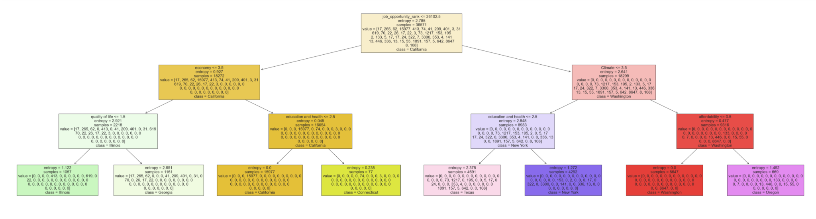

**Table 1**

|  |  |  |
| --- | --- | --- |
| Model | Advantages | Disadvantages |
| Decision Tree | Does not require normalization and Scaling of data | Small change in data causes a large change in the tree structure. |
|  | Is not affected by the missing values in the data. | Takes higher time to train the model. |
|  | A decision tree model is simple to understand and communicate to technical teams and stakeholders. | Not appropriate for applying regression for continuous variables. |
|  | Decision trees need less work for data preparation during pre-processing than other methods. | Because of the intricacy and time required, decision tree training is relatively costly. |

### K-Nearest Neighbors

The k-nearest neighbors (KNN) algorithm is a supervised machine learning classification algorithm that classifies a data point if it belongs to one of the two classes by calculating the distance between its nearest neighbors. This algorithm is called a lazy learning algorithm or a lazy learner it does not train the model when the training data is supplied instead the model gets trained only when a query is made. It is a non-parametric model, as it does not make any assumptions, rather it just looks around for the nearest points and classifies the data point.

**Figure 15**

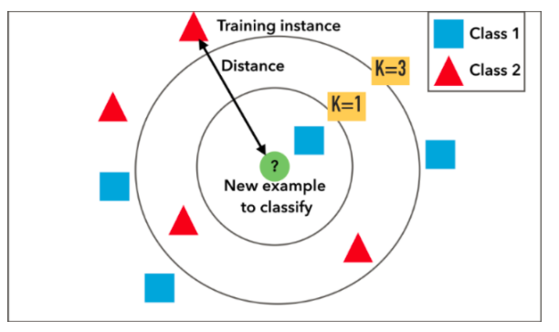

In the figure above, the data points are plotted in the feature space and when a new query point is given to the model, it first calculates the distance between the nearest points and based on the number of neighbors (k value) the query is classified as class 1 or class 2. The points belonging to class 1 are represented in blue and the other class in red. When the k value is one the query is classified as class 1 and if the k value is three the majority vote goes for the class 2 and hence classified as class2. The distance between the query point and the neighbours are calculated using four different ways namely Euclidean distance, Manhattan distance, Hamming distance, and Minkowski distance. The Euclidean distance is the most used metric among others.The length of a segment connecting two locations in either the plane or 3-dimensional space is measured by the Euclidean distance between them. It is the most straightforward method of expressing the distance between two places. The Pythagorean Theorem is used to calculate the distance between two points. The formula below is used for calculating the Euclidean distance where p and q are the two points in the feature space, qi and pi are the vectors starting from the origin, and n denotes the n space.

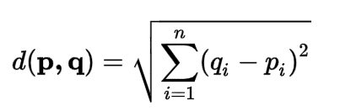

The k value is important to obtain best results from the model. Suppose if the k value is very low then the model gets over-fitted and it may fail to generalise if a new unseen data is given. It may perform well on the training data but not on the unseen dataset. On the other hand if the k value is large, the model does not perform well on both training and test datasets. Hence we end up with an underfitting model.There is no particular method to select the K value. Hence, different k values are given to the model and the corresponding accuracy score is noted. The results are plotted in a graph and based on the high accuracy score the k value is selected.

To predict the best location for an individual based on the features, the K-NearestNeighbour model first determines the best k value, this is done by plotting the accuracy scores for different k values during the training process, then based on the selected k value the distance between the query point and the neighbouring data points are measured. The problem domain considered is a multi class classification hence it has 52 classes.The majority score is calculated among the nearest neighboring classes, and the query point is classified based on the highest majority class.

**Table 2**

|  |  |  |
| --- | --- | --- |
| Model | Advantages | Disadvantages |
| KNN | It's straightforward to comprehend and apply. | Because it saves all of the training data, the associated calculation cost is substantial. |
|  | It may be used to solve problems involving classification and regression. | It needs a large amount of memory storage. |
|  | Because there are no assumptions about the underlying data, it's perfect for non-linear data. | K's value must be determined and If N is large, prediction takes a long time. |
|  | It is inherently capable of dealing with scenarios involving many classes and with enough representative data, it can perform well. | Sensitive to non-essential characteristics. |

### AdaBoost:

The Boosting method seeks to develop a powerful learner from the mistakes of numerous weaker models, just how humans learn from their mistakes and strive not to repeat them in the future. To begin, you must first create a model using the training data. Then you develop a second model based on the first, attempting to decrease the prior model's flaws. Models are added in a sequential order, each one correcting the one before it, until the training data is properly predicted or the maximum number of models is reached. AdaBoost is one of the ensemble techniques. AdaBoost is a prominent boosting approach that seeks to construct a strong classifier by merging many weak classifiers. A single classifier may not be able to reliably forecast the class of an item, but we may develop a powerful model by combining numerous weak classifiers, each learning from the others' incorrectly categorized objects. Any classifier may be used with AdaBoost to learn from its flaws and propose a more accurate model. For this reason, it is sometimes referred to as the "best out-of-the-box classifier."

**Figure 16**

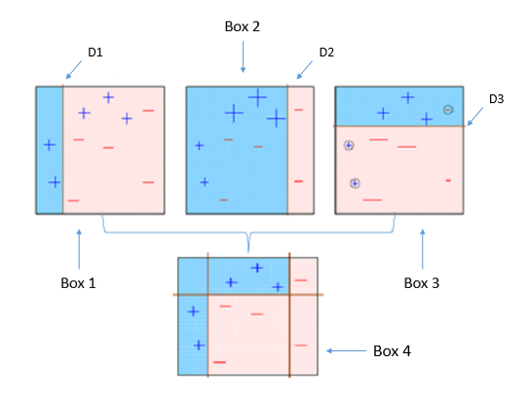

The first step is to build a weak classifier (such as a decision stump) on top of the training data using weighted samples. The importance of being correctly categorized is shown by the weights of each sample. For the first stump, we give equal weight to all of the samples. We next design a decision stump for each variable and test how effectively each stump classifies data into their intended classes in the second stage. In the following step, the wrongly classified samples are given extra weight so that they may be identified correctly in the next decision stump. Each classifier is also given a weight depending on its accuracy, which implies that a high accuracy equals a high weight. Following that, the processes will be repeated in a loop until all of the data points are correctly categorised or the maximum iteration level is achieved.



For each data point, we calculate the weighted samples. AdaBoost gives each training sample a weight to determine its importance in the training dataset. When the given weights are substantial, that set of training data points is more likely to influence the training set. In the same way, when the allocated weights are low, they have little impact on the training dataset.



Because the weighted samples always add up to one, each individual weight's value will always be between 0 and 1. After that, we use the method to calculate the real effect of this classifier in categorizing the data points.



The value of Alpha indicates how important this stump will be in the final categorization. The total number of misclassifications for that training set divided by the training set size equals Total Error. By entering in various values of Total Error ranging from 0 to 1. It's time to update the sample weights, which we had previously assumed as 1/N for each data point, after entering in the real Total Error values for each stump. There are two possible outcomes for alpha: positive or negative. When the expected and actual output align, Alpha is positive (the sample was classified correctly). We reduce the sample weight from what it was previously because we're already performing well. When the projected output does not match the actual class, Alpha is negative. We need to enhance the sample weight in this situation so that the same misclassification does not occur in the following stump. This is how the stumps owe their existence to their forefathers.

**Table 3**

|  |  |  |
| --- | --- | --- |
| Model | Advantages | Disadvantages |
| AdaBoost | Overfitting is not a problem with AdaBoost. | Adaboost requires a high-quality data collection. |
|  | AdaBoost may be used to increase the accuracy of your weak classifiers, allowing it to be more versatile. | Before implementing an Adaboost method, it is necessary to eliminate noisy data and outliers. |
|  | Adaboost is being used to categorize text and images rather than binary classification tasks. | In addition, AdaBoost has been shown to be slower than XGBoost. |

### XGBoost

The XGBoost is a boosting ensemble technique which creates multiple models, learns from the mistake of the previous model and the final model will have a very less error. The XGBoost algorithm is a variation of the gradient boosting technique that considers the expected value as well as the residue. The learning in the gradient boosting algorithm happens by optimizing the loss. The XGBoost is a very popular algorithm as it aids in improved performance and accuracy.

**Figure 17**

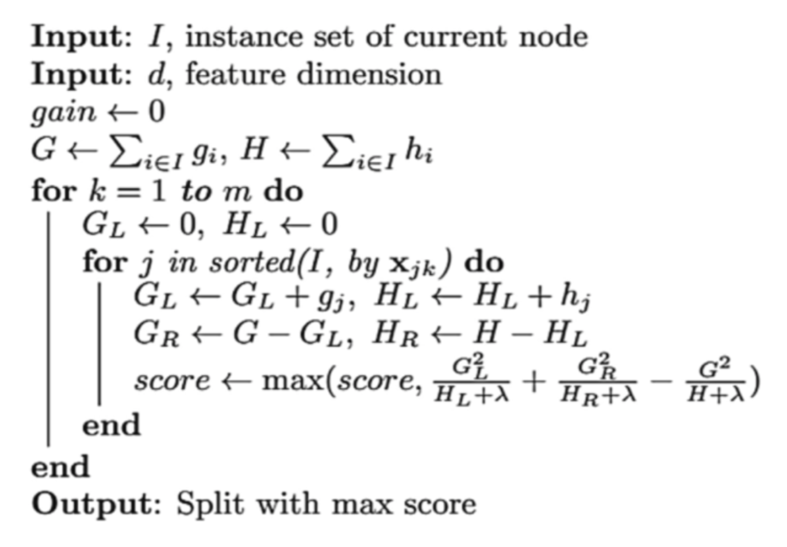

The above pseudocode is implemented to calculate the maximum similarity score. The left tree residual values are squared, and all the values are added together to yield the numerator, as shown in the equation above. The number of residual values is equal to the sum of the probability multiplied by one minus the probability gives the number of residual values, this gets added up with the regularization parameter. The regularization parameter can be modified to increase the speed of the model and to control overfitting of the model. Similarly, the similarity score for the right leaf is also calculated. The information gain of the root node is calculated using the below formula where the left and right trees similarity is calculated and subtracted by the similarity of the root node.

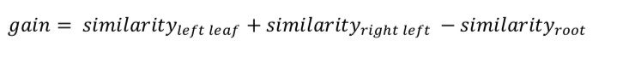 The same process is repeated by combining different residual values for all the features to get the best split. The splitting will stop when the leaf node has only one residue. The XGBoost algorithm builds many decision trees and hence the trees with minimum gain must be pruned to get the best model. If the gain is less than the complexity parameter, then that node will get pruned. The final prediction of the model is calculated, where the Etta is the learning rate which can range from .1 to .3 calculates the updated prediction for that record, as well as the new residue. The process is repeated until the residual is very small, and the model has been properly trained.

𝑝𝑟𝑒𝑑𝑖𝑐𝑡𝑖𝑜𝑛 = 𝑖𝑛𝑖𝑡𝑖𝑎𝑙 𝑝𝑟𝑒𝑑𝑖𝑐𝑡𝑖𝑜𝑛 𝑣𝑎𝑙𝑢𝑒 + (∈ 𝑥 𝑜𝑢𝑡𝑝𝑢𝑡 𝑣𝑎𝑙𝑢𝑒)

**Figure 18**

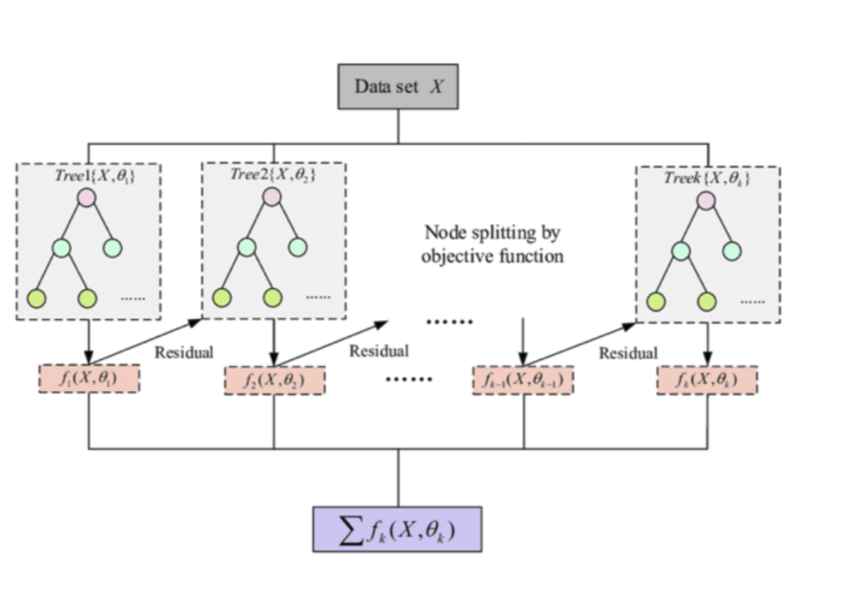

The above architecture explains the working of the XGBoost technique. The algorithm calculates the probability based on the target feature. The residue is the difference between the target feature and the probability. The data is now split based on any one of the features in the dataset. The selected feature is the root node of the tree. The decision tree is constructed by taking the value of the residue. The XGBoost must always have a binary split and hence irrespective of the number of groupings of the root node the tree will have only two leaves. This is continued until the residue becomes very low. The similarity score is calculated between the two leaf nodes by using the below equation where the residue from each tree is squared and divided by the sum of the number of residual values and the regularization term lambda.

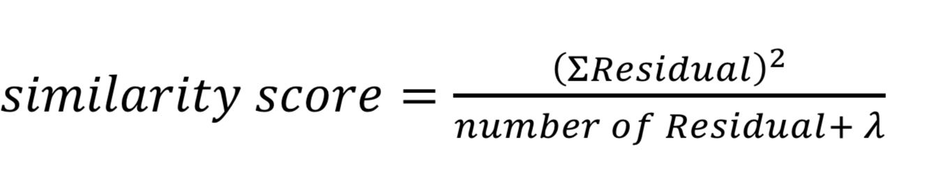

**Table 4**

|  |  |  |
| --- | --- | --- |
| Model | Advantages | Disadvantages |
| XGBoost | The overfitting problem is handled  by using the regularization technique which is inbuilt in the model. | The model does not perform well on the unstructured data. The model requires a large training set. |
|  | High computational power uses parallel processing. | It is very sensitive to outliers. |
|  | Handles missing values and Runs cross-validation in each iteration to get the best possible output. |  |

# Results

Using machine learning to build prediction models, we employed Decision tree, K- nearest neighbor, AdaBoost, and XgBoost. Each of the four models provided excellent accuracy scores. We achieved a higher accuracy rate with AdaBoost when compared to the other models.

## Decision tree

In order to calculate the information gain for the Decision Tree, we used Gini. We also used parameters such as random state 100, maximum depth of the tree was 3 and minimum sample leaves was 5. As a result of the decision tree model, we were able to accurately predict 82.5% of the locations based on the preferences. A learning curve is a graph that depicts the validation and training scores of an estimator for varying numbers of training samples. This is a technique for determining how much extra training data benefits us and whether the estimator suffers from variance or bias problems. To find out whether the model is overfitting or underfitting, we used a learning curve to analyse the decision tree model. So we started analyzing the data with a small training size and progressed to a large training size. During that process of building the decision tree model, we found that it overfits slightly when we have a smaller training data set. However, as the training data set grows, the built decision tree model does not overfit. We also determined the accuracy score for the training dataset and testing dataset in order to know how well the model fit with the training dataset. Our results showed training accuracy of 87.829% and testing accuracy of 87.826%. The testing accuracy is, therefore, 0.003% less than the training accuracy.

The Entropy gives a higher accuracy rate than Gini after tuning the model with hyperparameters where information gain is found. As a result, we used Entropy as the information gain for the decision tree. The best-fit hyperparameters were also determined by grid searching. In that, we determined that a maximum depth of five must be maintained, and a minimum of five leaves must be collected. When the parameters of the decision tree were tuned, the accuracy of the decision tree reached 95%.

**Figure 19**

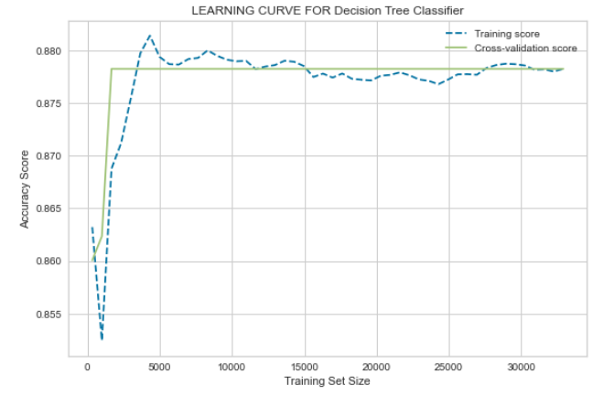

**Figure 20**

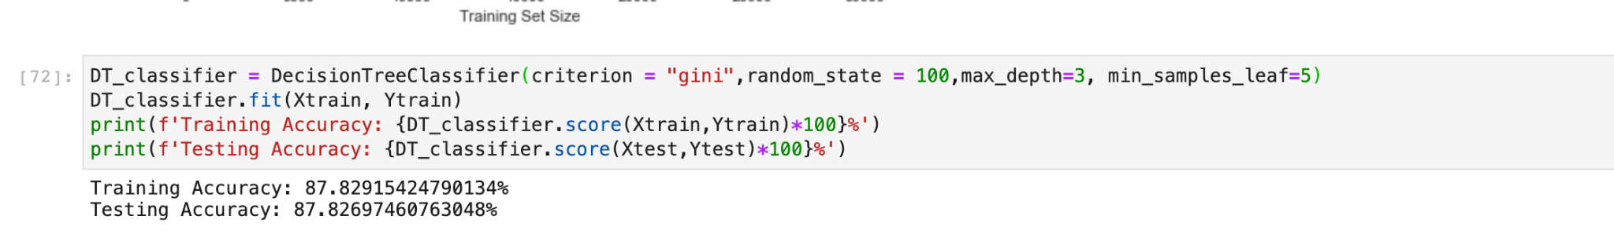

**Figure 21**

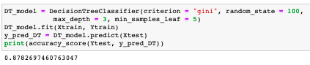

**After hyper tuning:**

**Figure 22**

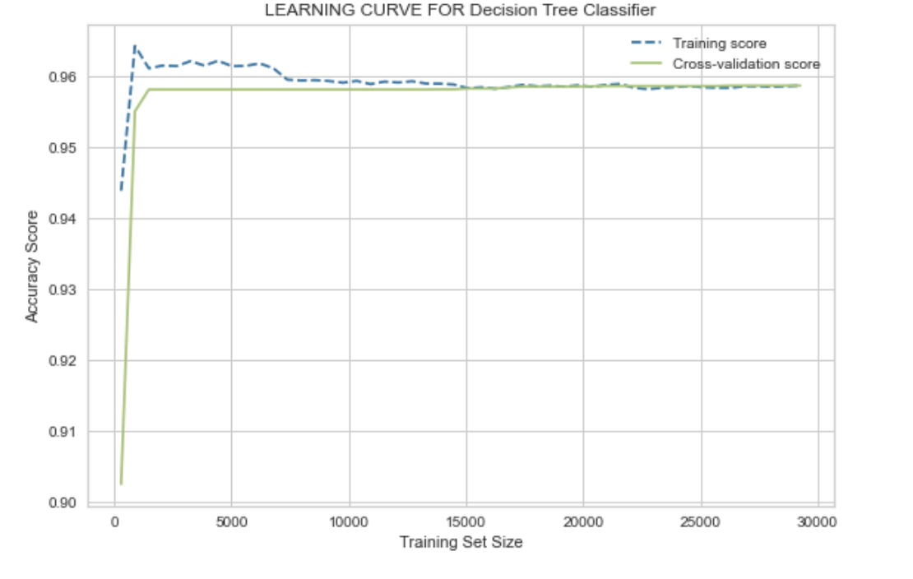

## K- Nearest Neighbor

In order to predict the location based on the preference we used K - Nearest neighbor. In that we used the K value as 12 to find how the model performs. After building the K - Nearest neighbor algorithm using Scikit-learn library the model predicted the target classes with 69% of accuracy. As we mentioned earlier, we plotted a learning curve graph to find whether the model is overfitted or under fitted. The graph clearly explains the built model is overfitted because the gap between the cross-validation line and training score is large. Both the cross-validation line and training score are not overlapping even as the size of the training dataset grows. Also, to know about the generalization of the model we found the accuracy score for training and testing dataset. The training accuracy score is 73% and testing accuracy score is 70%. This states that K- Nearest neighbor performs 3% less when the model is exposed to new data than the training data. Therefore, we can say the K - nearest neighbor model is overfitted for our problem domain. We turned the hyperparameters in such a way that the performance of the model improves.

By determining the best K value for k - Nearest Neighbor, we found that 12 was the most suitable K value. We achieved 90% accuracy using this K value. Nonetheless, the K- nearest neighbor model does not enhance accuracy. Moreover, the model remains overfitted for our problem domain.

**Figure 23**

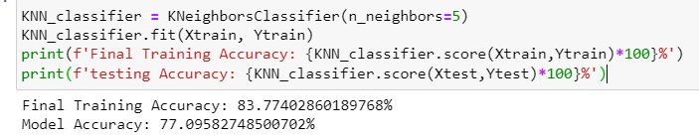

**Figure 24**

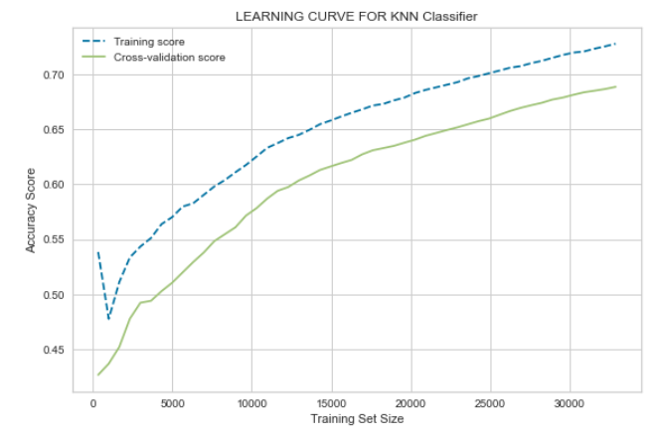

After Hyper Tuning:

**Figure 25**

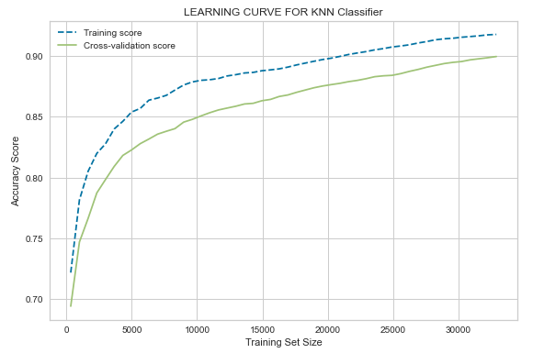

## AdaBoost

AdaBoost is popular among ensemble techniques because it is not susceptible to overfitting. In the multi-classification problem, the location must be predicted. We used AdaBoost to solve it. As a prediction, the estimator value was set at 50, and the learning rate was set at 1. This resulted in a low accuracy rate of 79%. Despite increasing the training size, Adaboost was unable to achieve high accuracy rates. The training grew in size, and there were lots of ups and downs. In the graph, we can see that the accuracy rate of the AdaBoost model starts to decrease after 30000 training sessions. However, the model has not been overfitted nor is it under fitted. Due to the fact that both the training score and the cross-validation score were the same, but the training size was increasing. This resulted in both curve lines overlapping. Our ROC curve graph shows that the area under the curve score for some of the multi classifications is smaller. The reason for this is that the area under the curve score for others was very high while the area under the curve score for others was very low. As a result, we can understand why the AdaBoost model performs poorly. Performance needs to be improved by tuning the hyperparameters in order to increase the model's efficiency. Our goal was to identify the hyperparameters that were the most suitable fit by grid search.

By using grid search, we were able to find the hyperparameters for the AdaBoost model. These hyperparameters were that the estimator value should be 500 and the learning rate should be 0.1. Once the model was trained, it was tested. In that case, we achieved 99.89% accuracy. We also looked at the learning curve, and although the size of the training increases, the curve has a smooth line at 99% accuracy. Additionally, the model does not appear to be overfit since the cross-validation score and training score were the same and overlapped.

**Figure 26**

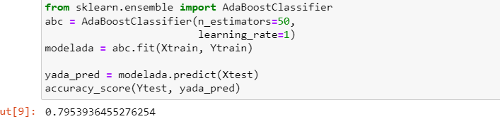

**Figure 27**

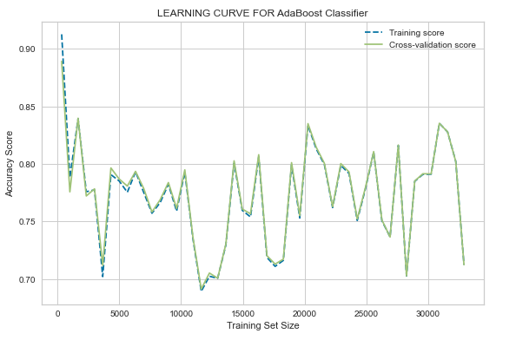

After Hyper tuning:

**Figure 28**

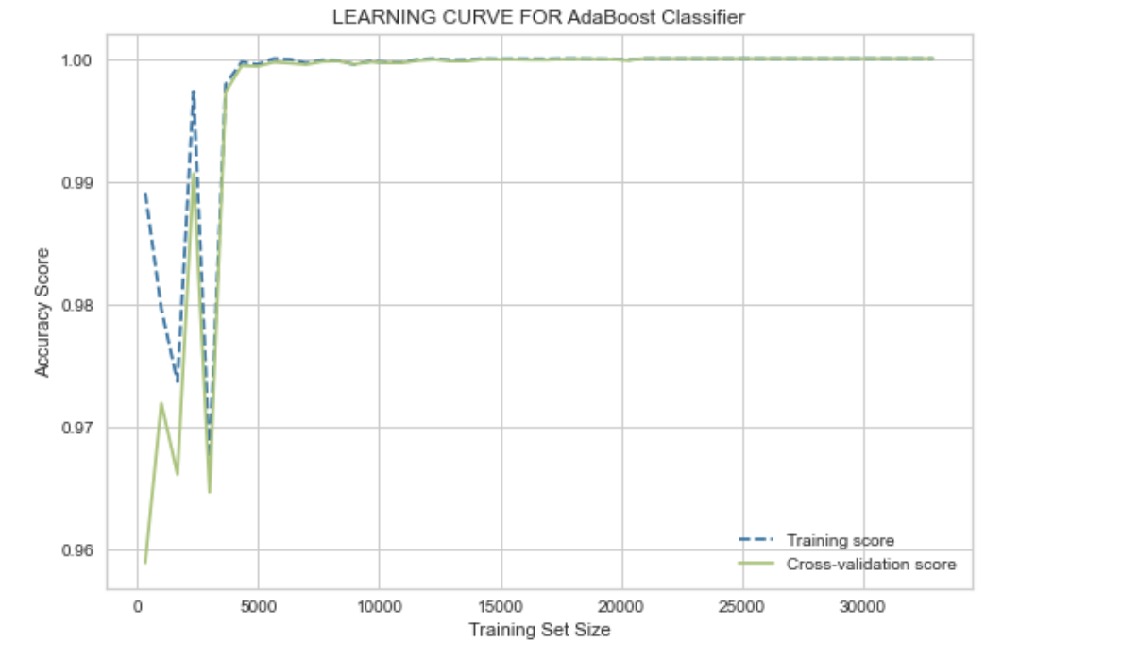

## XGBoost

Another one of the boosting techniques is XGBoost, which is known for its speed performance. A XGBoost model is three times faster than the AdaBoost model but has a higher tendency to overfit. A prediction of the location is critical in the multi classification problem. XGBoost was used in this case. Our model's estimator was set at 500, while the learning rate was set at 1. We also set the maximum depth to 10 in an effort to avoid overfitting. This resulted in an accuracy rate of 99.95%. Although the training size was increased, XGBoost maintained a high accuracy rate despite the increase. Training size increased, and the cross-validation and training scores exhibited a stable trend with higher accuracy rates. In addition, the model wasn't overfitted. With a training size of 30000, we can see that the accuracy rate of the XGBoost model is around 10%. In this case, the two curve lines overlap. According to the ROC curve graph, all of the multi classifications have a higher area under the curve score. As shown in the ROC curve graph, all of the multi classifications have a higher area under the curve. This is a reliable indicator that the XGBoost model is performing very well. Additionally, the model can be overfitted due to this factor as well. Consequently, we need to tune the hyperparameters so that the model does not overfit. By grid search, we sought to identify the hyperparameters that were most suitable for the model.

The hyperparameters of the XGBoost model were identified using grid search. These hyperparameters were as follows: the estimator value was to be 50, the learning rate was to be 0.1, and the tree depth was to be 3. A model validation process took place after the model was trained. We achieved an accuracy of 99.23%. Specifically, it indicates that before hyper tuning the model was overfitted, but now after hyper parameter tuning, the model has been recovered from the overfitted condition. Moreover, we looked at the learning curve, and while the size of the training increases, it has a smooth line at 99% accuracy. Further, the model's cross validation and training scores were the same and overlapped, suggesting that it is not overfit.

**Figure 29**

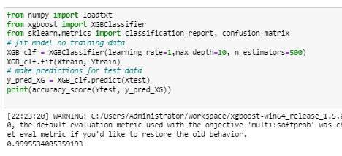

**Figure 30**

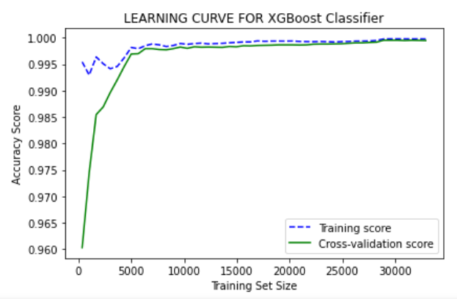

After Hyper tuning:

**Figure 31**

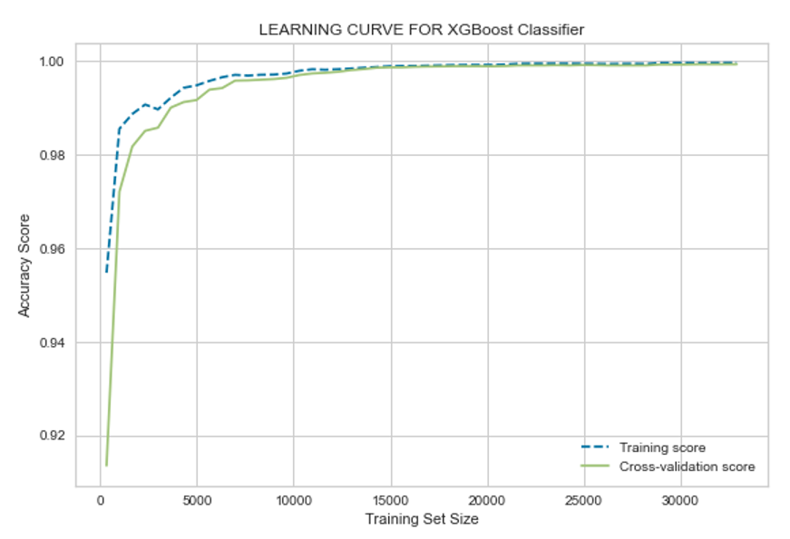

# Discussion

According to our results, Decision Trees reduce bias and are high variance models. Therefore, we thought that it would be an ideal fit for this problem domain as we are dealing with multiclass target values. Though the Decision Tree model achieved 95% accuracy in this domain, the precision, recall, and F1- scores are very poor. This indicates that the Decision Tree model is not performing well in this domain. The true positive rate is also low. However, a few of the multi-class target values were slightly low under the curve, despite having a favorable Roc curve. The decision tree is not the right model for our problem domain when compared to other models. If we are dealing with multi-class target variables, we can use K-Nearest Neighbor. We found that even after tuning the hyperparameter for improved performance, the model was not able to perform properly. In spite of the model achieving 90% accuracy, the K-NN model was overfitted; it only performed well with training datasets and not with testing datasets. In addition, we find that precision, recall, and F1-score are all very low. This also indicates that the model is not performing well. Accordingly, K-NN is not the most appropriate fit model. Therefore, ensemble methods were used to select the most suitable model. Due to the multi-class nature of the target variable, we tested boosting techniques such as AdaBoost and XGBoost. The main feature of XGBoost is its speed, as well as its ability to handle multi-classification problems. We achieved 99.23% accuracy with XGBoost. Additionally, it obtained a neat ROC curve and the area under the curve was also high. The prediction was completed faster with XGBoost. When we compared the XGBoost to the AdaBoost, its precision, recall, and F1-Score were slightly higher. As a result of this, XGBoost performed well but Adaboost performed much better than XGBoost when it came to our problem domain. Due to this, XGBoost is not a suitable fit for our application. When it comes to AdaBoost, AdaBoost performed very well from all angles. Despite the fact that the model reached a 99.89% accuracy rate, it was not overfitted. 99.89% accuracy rate has the highest accuracy among all models. This model also obtained the most accurate ROC curve. Also, the area under the curve was very large. Furthermore, the True positive rate, precision, recall and F1-score was high in comparison with other models. Our conclusion is that AdaBoost is the most well-suited model for our problem domain in all aspects.

# Evaluation and Reflection

The model must be evaluated on various metrics to measure the accuracy and to know how well the model performs on the new input data. The various evaluation metrics are the confusion matrix, accuracy, precision,recall, F1-score, learning curves and ROC/AUC.

The confusion matrix shows the count of the correctly and incorrectly predicted values. The terms in confusion matrix, the True Positive (TP) if both new and initial values are yes, the True Negative (TN) if the initial and new values are no, the False Positive (FP) if the new value is yes but the initial output is no, False Negative (FN) if the new output is yes but initial result is no.

The accuracy score is calculated by adding the true positive and true negative values divided by the other classifications namely TP, TN, FP, and FN as shown in the equation below. The recall is another measure to evaluate the model. The recall is calculated by dividing TP by TP and FN, it defines the percentage of results correctly predicted by the model. The precision is a matrix which measures the predicted results which are relevant. The precision is calculated by dividing TP and the summation of TP and FN as shown in the equation below. The F1 score is a method of evaluation that involves multiplying precision and recall and dividing the result by the sum of accuracy and recall as shown in Equation. F1 score marks the balance between precision and recall.

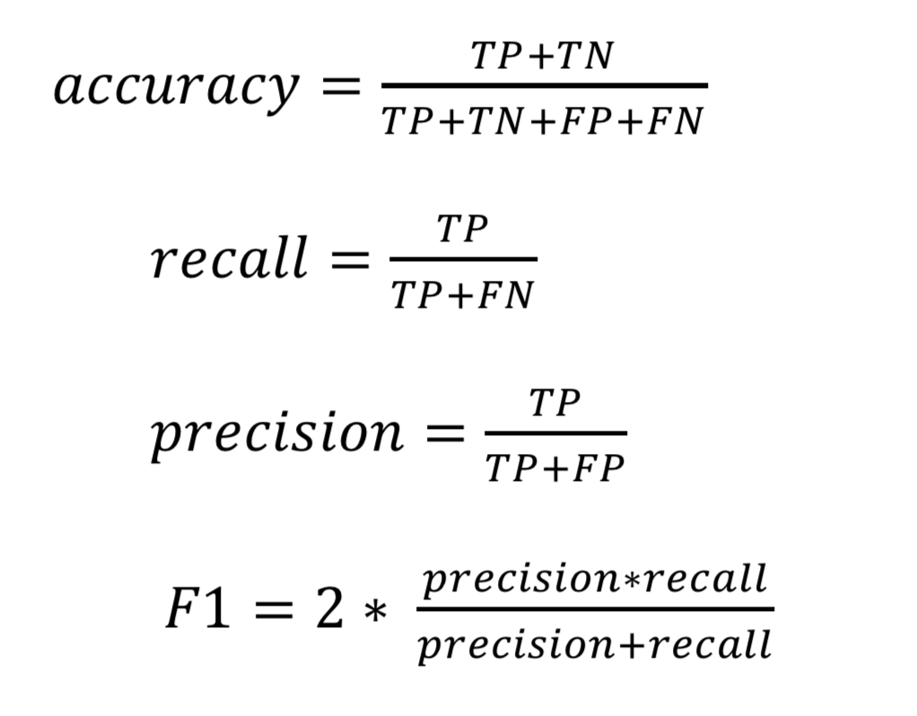

The AUC/ROC curve is an evaluation metric for classification problems. The AUC reflects the degree or measure of separability, while the ROC is a probability curve. It indicates how well the model can discriminate between classes. The AUC indicates how well the model predicts 0 classes as 0 and 1 classes as 1. The higher the AUC, the better the model predicts 0 classes as 0 and 1 classes as 1. By analogy, the higher the AUC, the better the model distinguishes between the classes. The True Positive Rate (TPR) and the False Positive Rates   
(FPR) are calculated to plot the ROC curve. The TPR is on the y-axis and FPR on the x-axis.

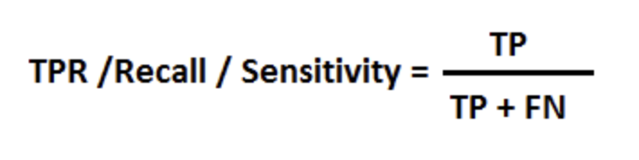

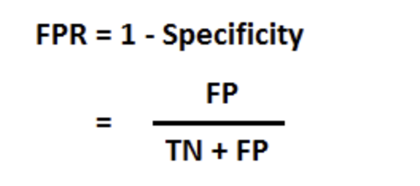

Receiver Operator Characteristic (ROC) graphs are plotted. The TPR is identified by calculating the recall metrics. The FPR is calculated by dividing FP by the summation of FP and TN. The Area Under ROC curve (AUC) compares two ROC curves of different models. The value of the AUC must be higher only then we can conclude the model will accurately predict the output.

## Decision Tree

The confusion matrix for the Decision Tree algorithm is shown in the diagram below. The actual values are plotted in the x axis and the predicted values in the y axis. The number of points for which the predicted label is identical to the real label is represented by the diagonal elements, whereas off-diagonal elements are mislabeled by the classifier. The greater the diagonal values of the confusion matrix, the more right predictions there are. Hence, the model has predicted most of the records correctly and only few records were incorrectly predicted.

**Figure 32**

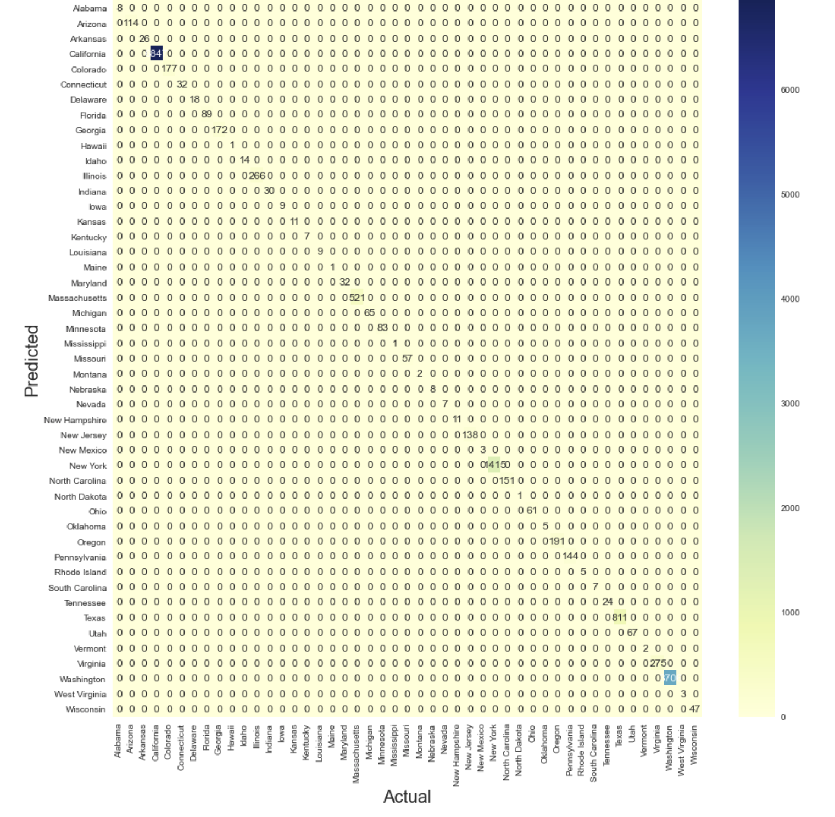

The ROC curve is plotted for all the states present in the target feature. It is used to measure the performance calculated by using the prediction scores. The ROC is the probability curve, where the probability of predicting each of the states are estimated and plotted. The curve for all the states is marked towards the left and the top corners indicating that the area under the curve is large for all the states. Also the micro average score of the ROC curve is estimated to occupy 100% of the area in the graph and the macro average 99% of the area. This shows the model performs well but we have to analyze other evaluation metrics in order to decide on the best model for the problem domain.

**Figure 33**

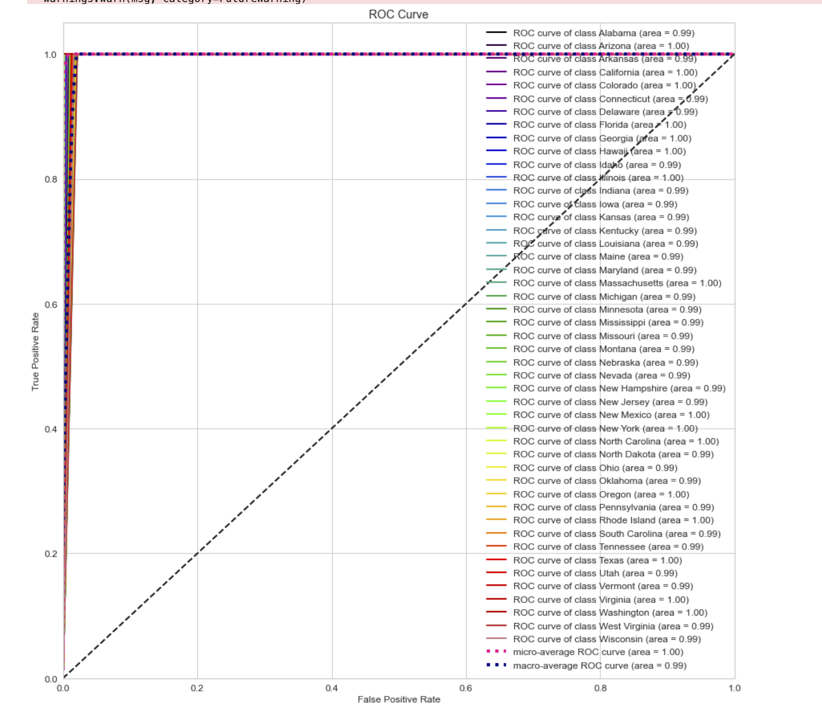

The K-fold cross validation is performed to measure the accuracy of the model correctly by performing 10 folds. Here, the dataset is split into n blocks where n-1 block was used for training and the remaining block for testing. This was carried out 10 times in order to capture the results of the dataset in various angles. The average accuracy measured was equal to 95% in all the folds. The image below shows the number of folds and the accuracy calculated for each fold.

**Figure 34**

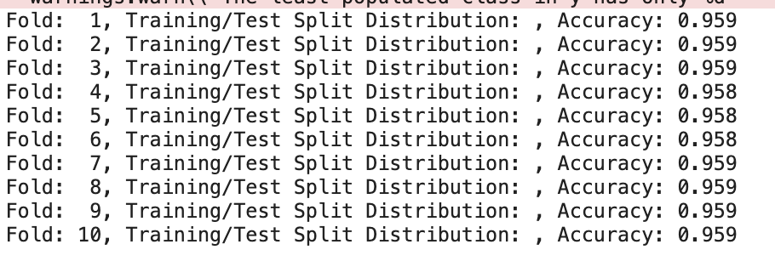

The precision, recall, F1-score is calculated. The precision is very important as it denotes the percentage of the relevant results rather than the irrelevant ones. Here, the precision score is very low and estimated to be 31% as shown in the Figure below. The recall is used to quantify the correct predictions among the total correct predictions that could have been made. Here, the recall value is also estimated to be 36% which is very low. The F1-score is the harmonic mean of precision and recall; it marks the model's accuracy on the dataset. This value is estimated to be 32% which is again a low value.

**Figure 35**

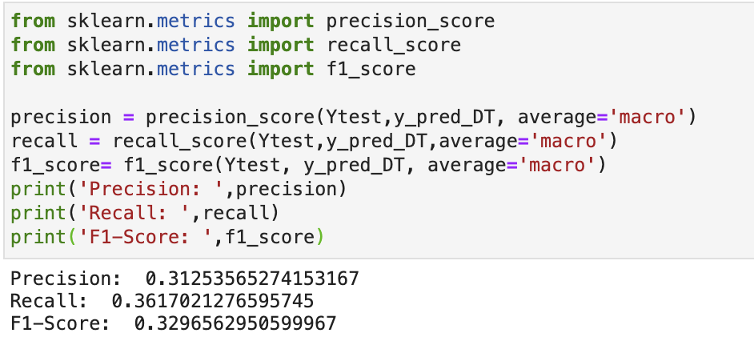

The training and testing accuracy of the model is then estimated to see if the model shows a good fit. The testing accuracy must always be more than the training accuracy. The training accuracy is 95.86% whereas the testing accuracy is 95.85% which is slightly low indicating that the model is overfitted to the dataset.

**Figure 36**

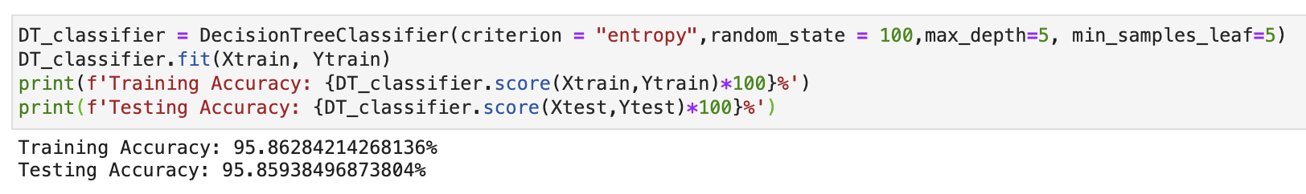

## K-Nearest Neighbor

The below image is the confusion matrix for the K- Nearest model. The diagonal indicates the count of the correctly classified records whereas the points off-diagonal are incorrectly classified. It can be seen that the model has incorrectly classified many records and hence the accuracy is not satisfactory. Other metrics must be evaluated in order to correctly assess the model.

**Figure 37**

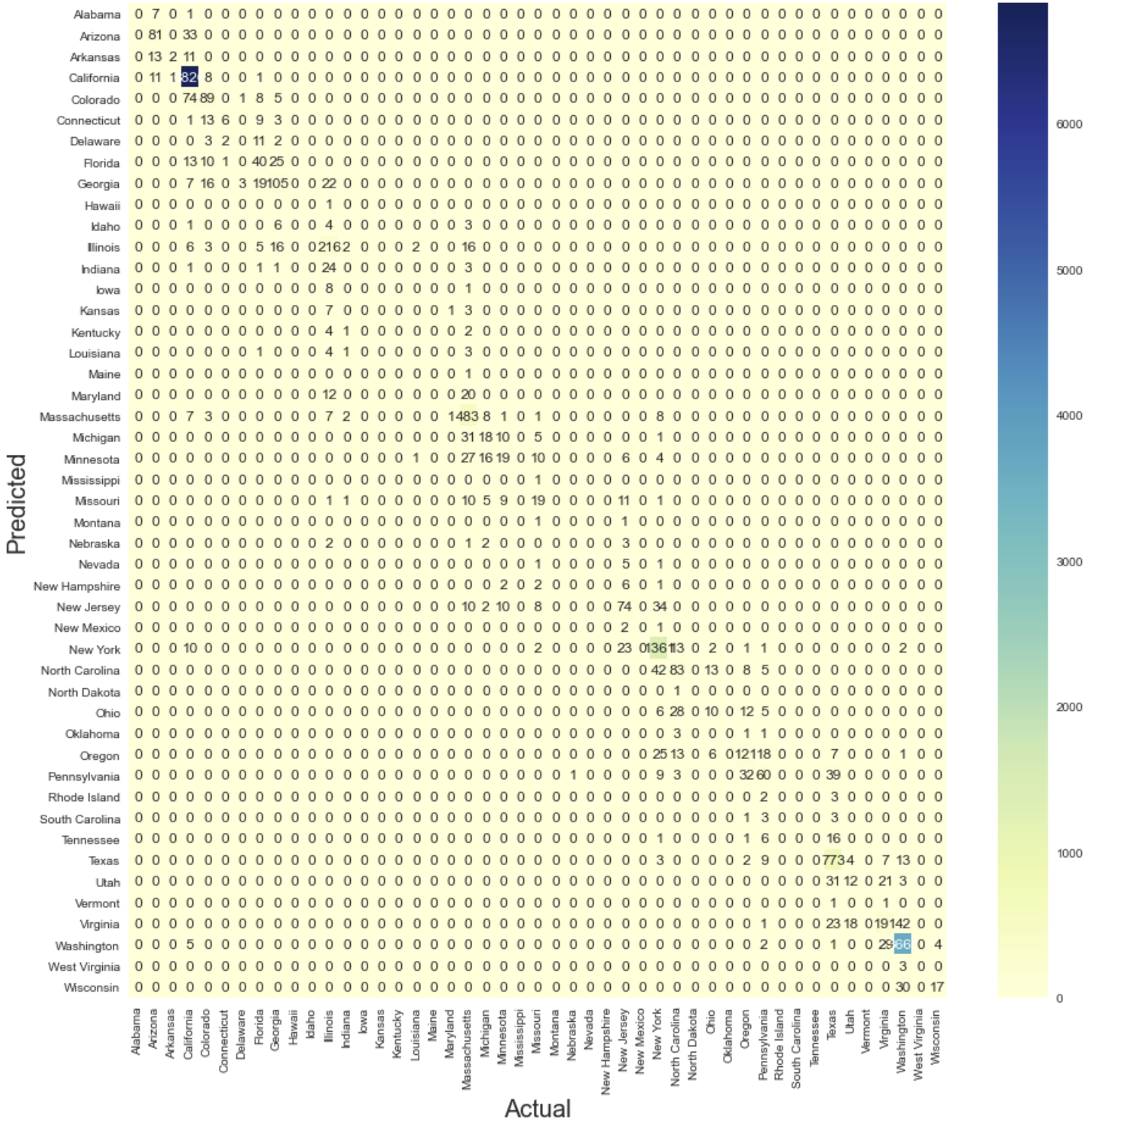

The ROC-AUC curve for the model is shown below. The area under the curve is different for each state indicating the least area occupied to be 86% and the highest is 100%. Here, when the micro average was analysed it was found that the average area was 100% whereas the macro average was 94%. The model is not performing well when compared to the decision tree.

**Figure 38**

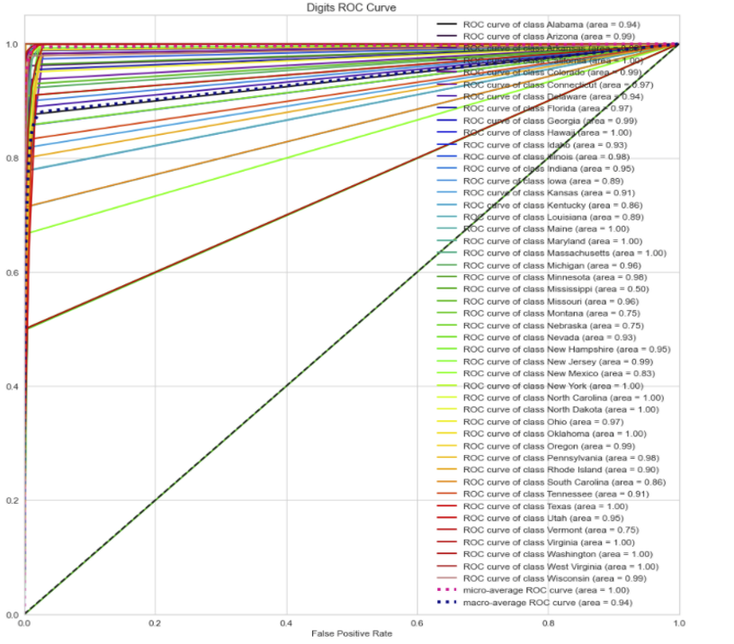

The k-fold cross validation is performed with 10 folds and it can be seen that the model gives different accuracy in each fold. The average accuracy of the model is estimated to be 90% and hence this model does not perform well for our problem.

**Figure 39**

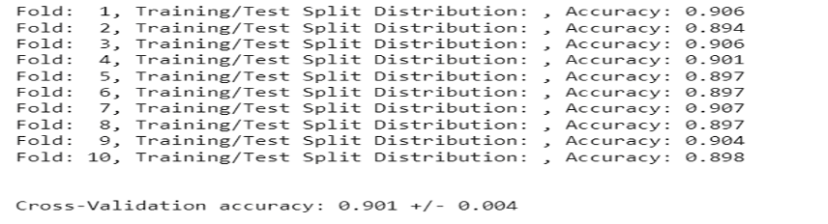

The next matrix is the precision, recall and F1-score. The precision value is significantly low, estimated to be 30%. The recall value is estimated to be 25% which implies that the model is not performing well. Lastly the F1-score with 26%.

**Figure 40**

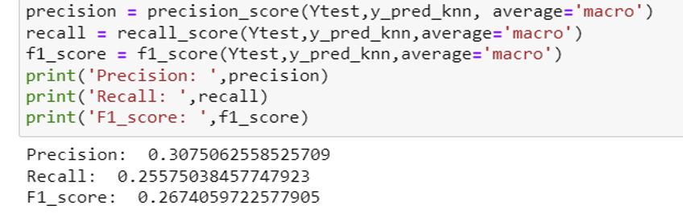

The training and testing accuracies are calculated. The model shows a training accuracy of 92% whereas the testing accuracy is 90%. The testing accuracy sis lower than the training accuracy hence the model is overfitting.

**Figure 41**

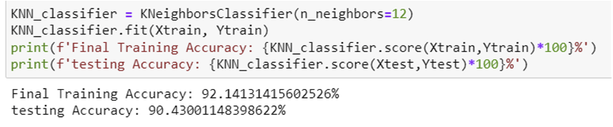

## Adaboost

The confusion matrix of the Adaboost model is illustrated below. The matrix shows that all the records were correctly predicted and there is no incorrect prediction. The model seems to perform well but its too early to judge. Hence, the other metrics has to be calculated before we conclude.

**Figure 42**

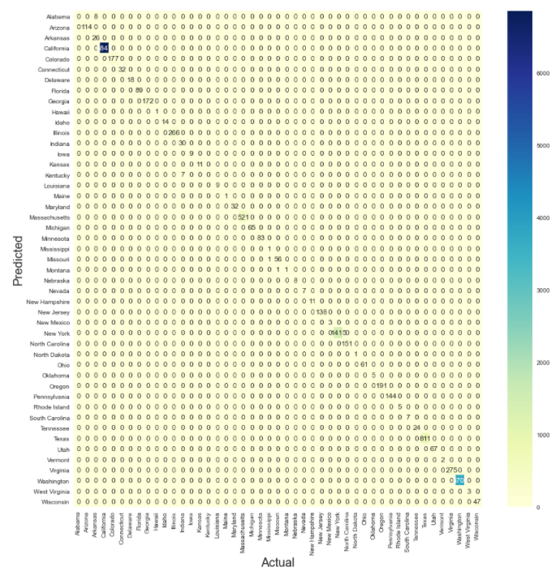

The AUC-ROC curve of the Adaboost model shows that all the states were correctly predicted, and the curve occupies 100% of the area. The micro and macro averages are also 100%. It is important to see if the model is overfitting the data.

**Figure 43**

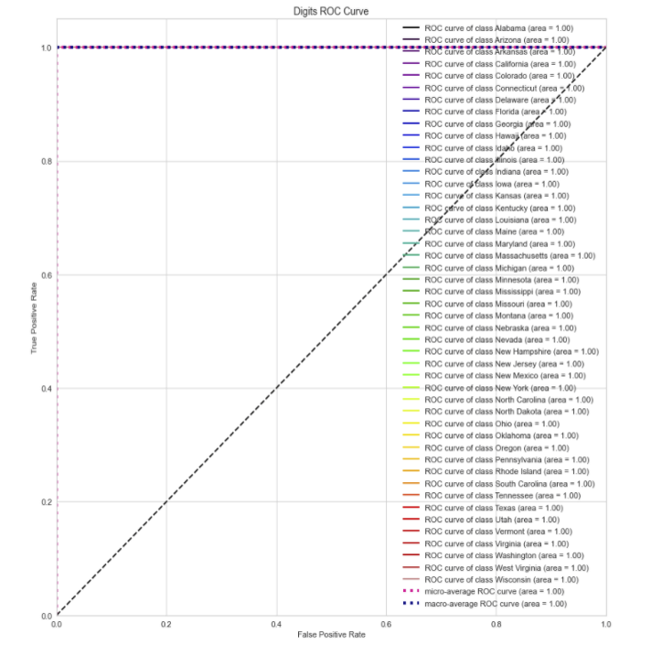

Here, k fold cross validation was carried out to assess the model’s accuracy in each fold with different training and testing sets. The model was validated with 10 folds, where each fold gave an accuracy of 99% and 100%. Hence the average accuracy was estimated to be 100%.

**Figure 44**

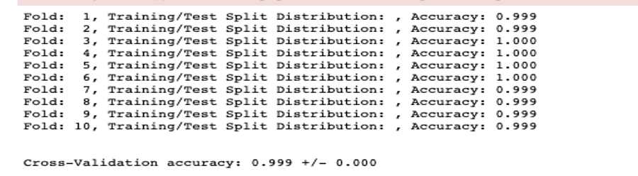

The precision, recall and the F1-score was calculated. The precision was estimated to be 94% which is a good number, indicating that more records were correctly predicted, and the recall score was 95%. Also, the F1-score was 94% indicating that the model is performing well.

**Figure 45**

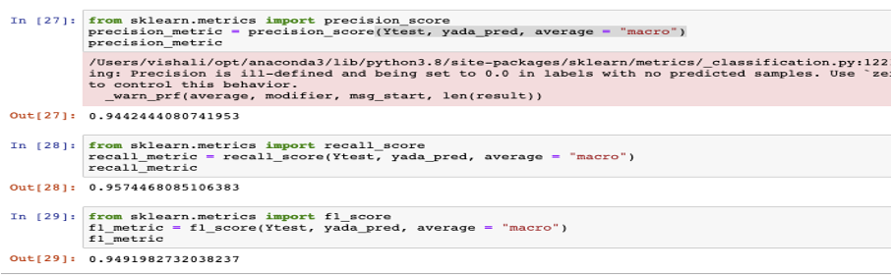

The training and testing accuracy were calculated. The training and testing accuracy were same indicating that the Adaboost is a good fit model.

**Figure 46**

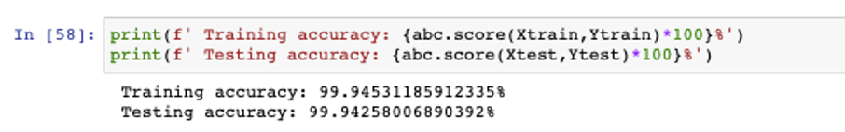

## XGBoost

The confusion matrix of the XGBoost model is illustrated below. The diagonals have the count of correctly classified records and the off-diagonal incorrectly classified records. The matrix clearly shows that all the records were correctly classified and there were no incorrectly classified records as that of the Adaboost model. Furthermore, the other metrics has to be evaluated to to qualify this model.

**Figure 47**

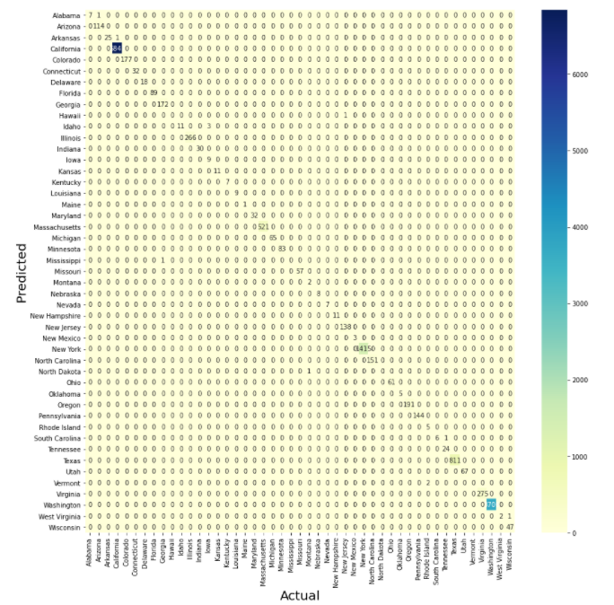

The AUC-ROC curve shows that the curve for all the states are 100% and the area under the curve is also 100% indicating that there was not incorrectly classified records. The macro and micro averages were also estimated to be 100%. The curve for the XGBoost model is illustrated below.

**Figure 48**

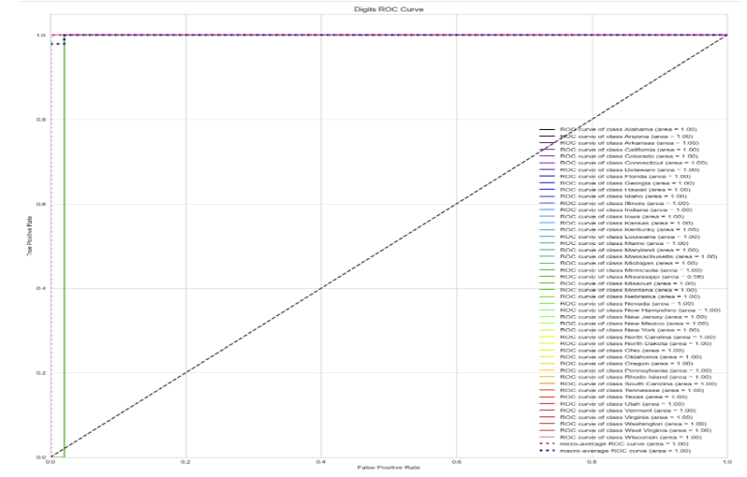

The precision score for this model was estimated to be 87% which is less than the Adaboost model. Also, the recall and the F1-Score is also low. Even Though the model was able to achieve 100% accuracy, the other matrices are low hence when compared with Adaboost, XGBoost is not performing well.

**Figure 49**

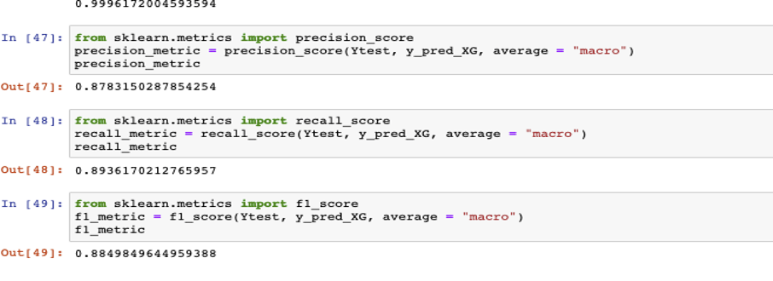

Furthermore, the training and testing accuracy is calculated to check if the model is overfitting or underfitting. The testing accuracy is slightly greater than the training accuracy hence the model is a good fit. The accuracy measures are illustrated below.

**Figure 50**

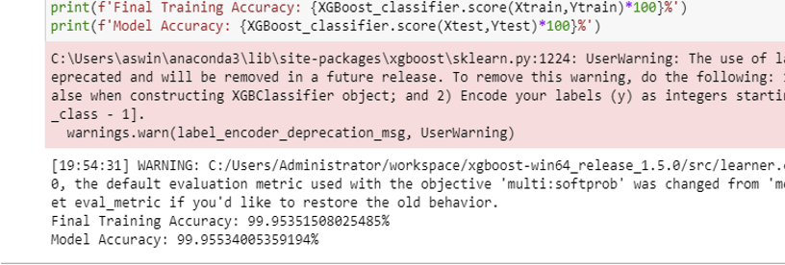

## Model Deployment

The last phase of the CRISP-DM methodology is to deploy the machine learning model. Based on the above evaluations and justifications we can conclude that the Adaboost boosting ensemble technique performed well for predicting the job location based on the employee preference. Model Deployment helps to visualize the predictions and make better decisions with it. Creating a web service for prediction is the easiest approach to deploy a machine learning model. There are many open-source libraries available, here Streamlite is used to deploy the job location prediction model. Streamlite is a popular open-source framework which is free of cost and purely written in python.

Once the Adaboost model is trained using the training dataset, a pickle file is generated. The pickle is used to serialize Python object structures, which is the conversion of a memory object to a byte stream that can be saved as a binary file on disk. The below code snippet shows the model deployment using the streamlite library. The code is written and saved as a python file. Firstly, the pickle file is loaded, and the UI prompts the user to enter his preferences. Once the predict button is invoked the location for the user is predicted. The python file is invoked from the command prompt and the UI gets rendered onto the browser.

**Figure 51**

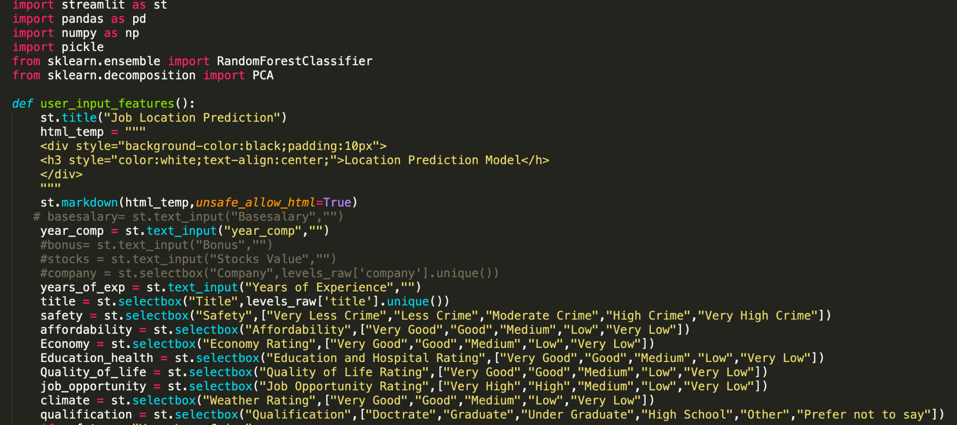

**Figure 52**

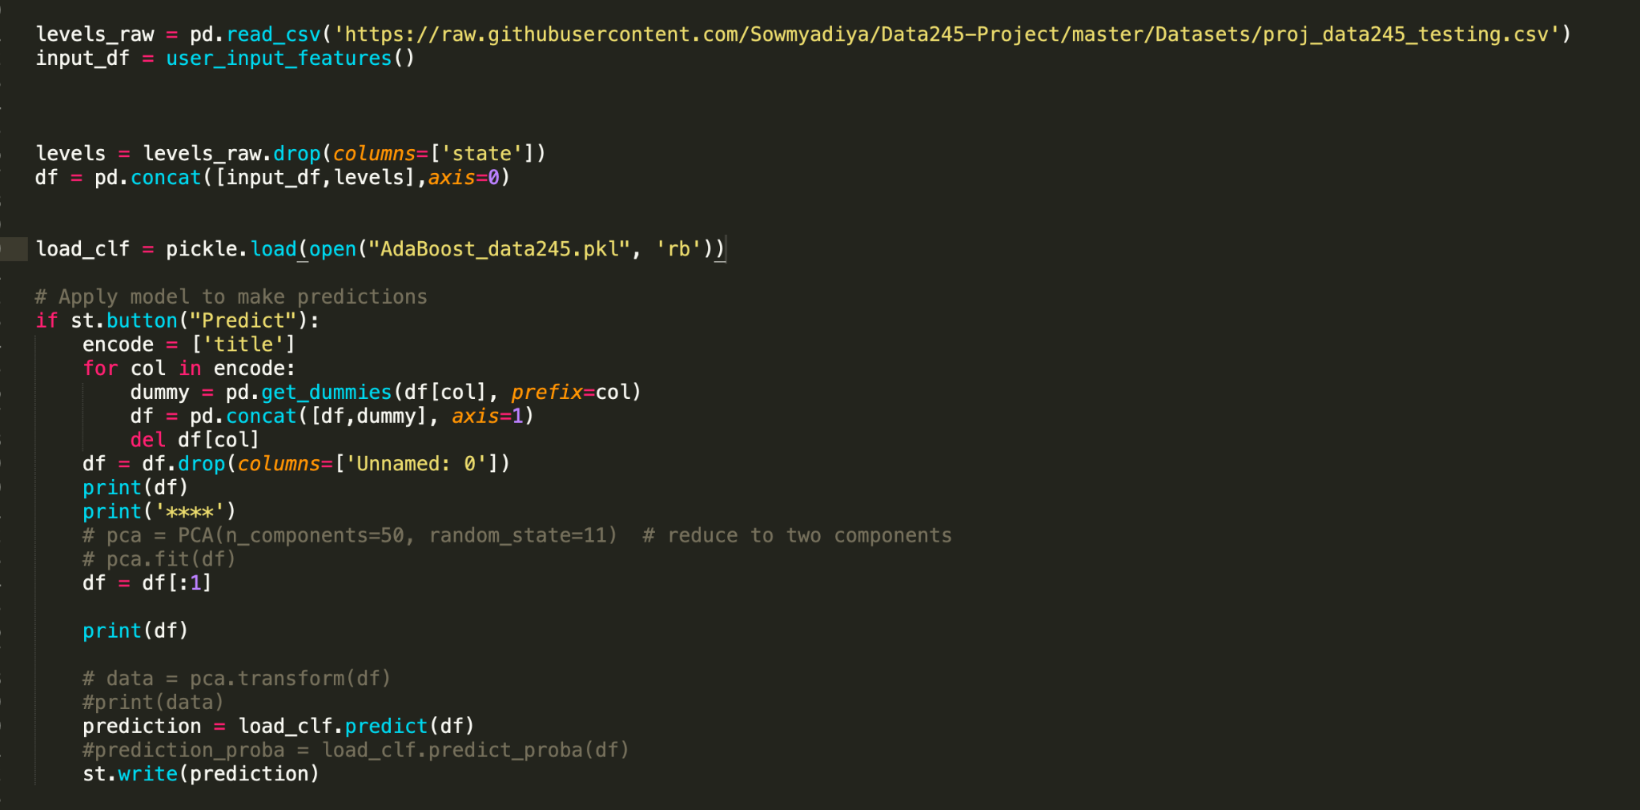

In the UI, the user is prompted to provide the yearly compensation, years of experience, title, safety, affordability, economy, education and hospital, quality of life, job opportunity rating, weather, and qualification. All these parameters are given to the model as a query to predict the desired location for the user. Once the predict button is hit, the query gets executed and the result is displayed on the screen.

**Figure 53**

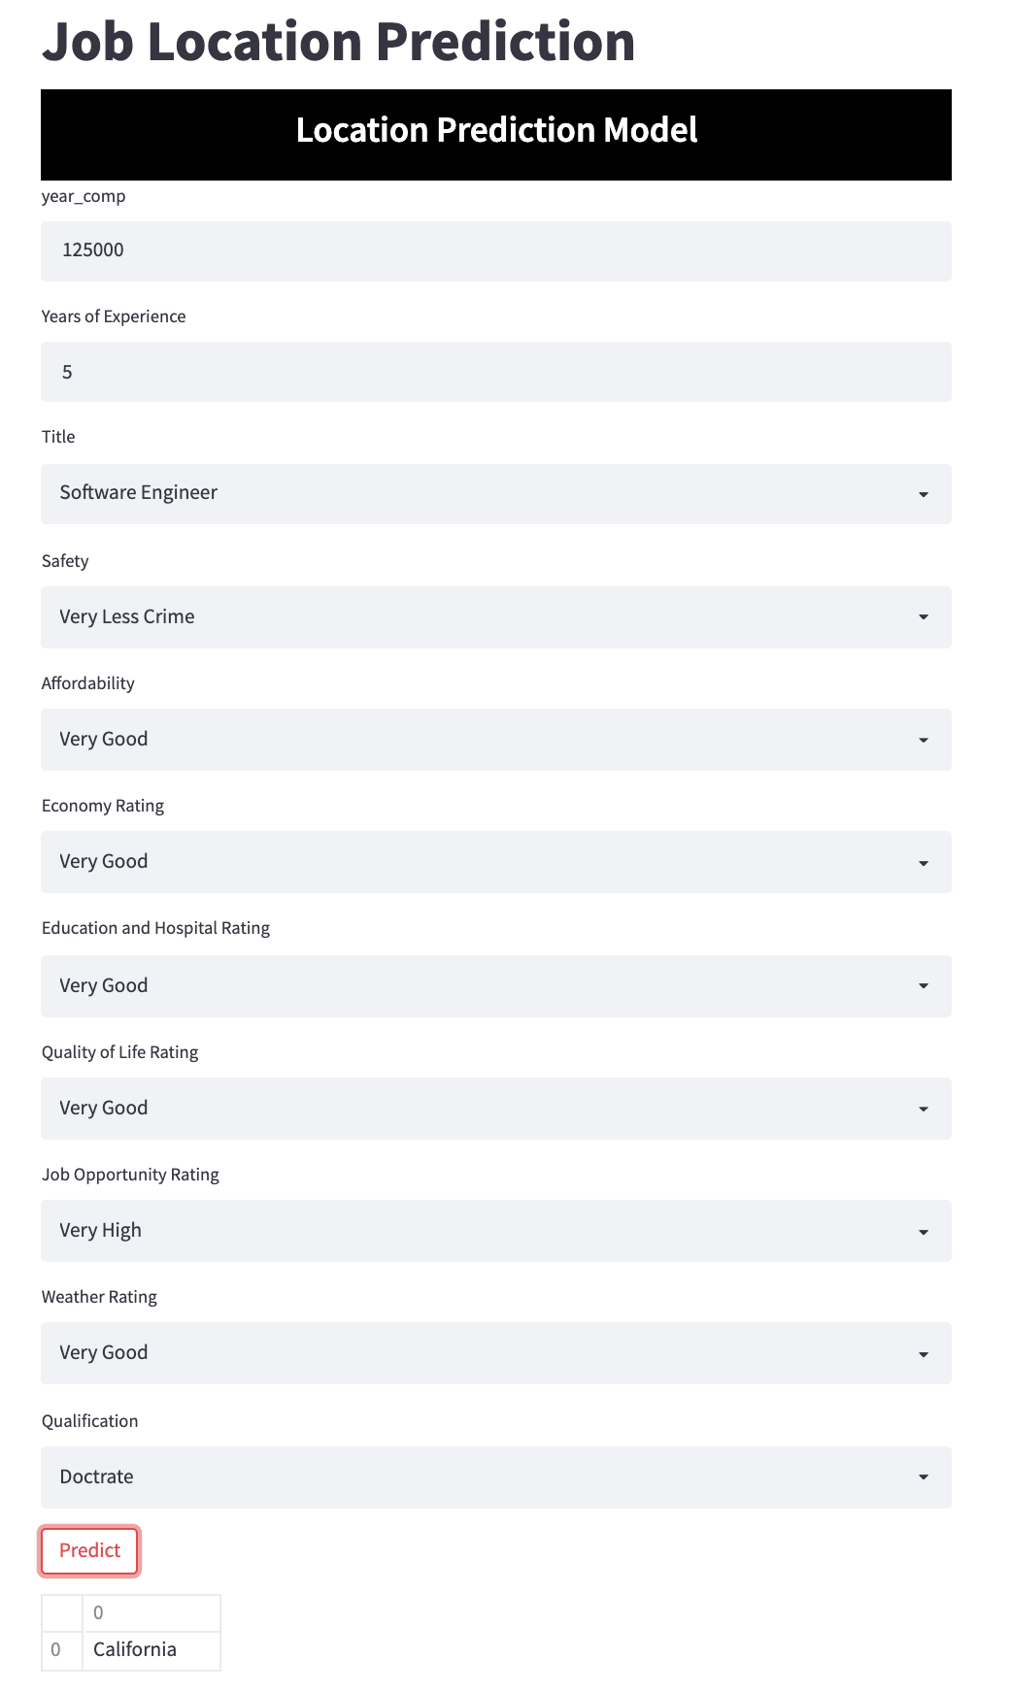

## 

## Future work

We have primarily concentrated on the states of the United States of America in our research. We would want to expand this initiative to include all nations since it would benefit every job seeker to be able to settle in a peaceful atmosphere that will allow him to perform better both personally and professionally. We will also include other parameters pertaining to job such as technical skills, certifications, special demands etc.

# References

*Applying data mining techniques in job recommender system for considering candidate job preferences*. IEEE Xplore. (n.d.). Retrieved December 3, 2021, from https://ieeexplore.ieee.org/document/6968361.

Jiang, M., Fang, Y., & Nguyen, A. (2018, April 23). *User click prediction for personalized job recommendation*. World Wide Web. Retrieved December 3, 2021, from https://link.springer.com/article/10.1007/s11280-018-0568-z.

Huynh, T., Nguyen, N., Xie, H., Chong, J., & Meng, M. (n.d.). *Job Prediction: From Deep Neural Network Models to Applications*. World Wide Web. Retrieved December 3, 2021, from https://arxiv.org/pdf/1912.12214.pdf.

  Sithiponporna, N., Tanlamaib, U., Chandrachaic, A., & Triukosed, S.,(Volume 13, Issue 6, 2020). *A Job Recommendation Machine Learning Model Using Elderly Lifestyles*. Retrieved December3, 2021, from https://ww.ijicc.net/images/vol_13/Iss_6/13637_Sithiponporn_2020_E_R.pdf.

Mughaid, A., Obeidat, I., Hawashin, B., & AlZu’bi, S.,(2019). *A smart Geo-Location Job Recommender System Based on Social Media Posts*. Sixth International Conference on Social Networks Analysis, Management and Security (SNAMS). Retrieved December 3, 2021, from https://ieeexplore-ieee-org.libaccess.sjlibrary.org/stamp/stamp.jsp?tp=&arnumber=8931854&tag=1